Match the definition with the term.

Terms | Definition
Queer
Gay
Bisexual
Pansexual
Asexual
Straight
Lesbian

Definitions
- A person who identifies as a woman who is emotionally, romantically, or sexually attracted to other people who identify as women
- A person who is emotionally, romantically, or sexually attracted to some members of the same gender. Usually used by people who identify as male, although it can be used to describe anybody attracted to the same gender as themselves
- A term some people use to identify themselves with a flexible and inclusive view of gender and/or sexuality. Can also be used as an umbrella term for the entire LGBTQ+ community. Historically, it has been used as a negative term for LGBTQ+ people. Some people, especially those of older generations, still find the term offensive while others embrace the term as an identity and a reclaimed and empowered word
- A person of any gender who is emotionally, romantically, or sexually attracted to people of a different gender
- Someone of any gender who has the potential for romantic, emotional, or sexual attraction to people of any gender, though not necessarily simultaneously, in the same way, or to the same degree. Acknowledges the existence of more than two genders
- A person of any gender who lacks sexual attraction or desire for other people
- A person of any gender who is emotionally, romantically, or sexually attracted to people of more than one sex, gender expression, or gender identity, though not necessarily simultaneously, in the same way, or to the same degree

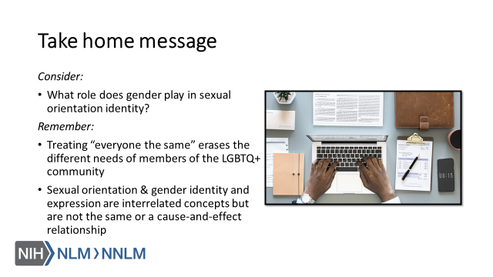

References:

- Human Rights Campaign. “LGBTQ Definition for Adults: Welcoming Schools.” Human Rights Campaign, URL to Source
- Brawbaw, Kasandra. “Allosexual, Demisexual, Bicurious - & Other Sexualities You Need to Know.” Refinery 29, 18 June 2019, URL to Source
- Brown, Eliza and Paula England. “Sexual orientation versus Behavior – Different for Men and Women?” Contexts.org, 29 February 2016, URL to Source

