Health Literacy and Treatment Adherence
A 2017 meta analysis looked at 220 studies of health literacy and treatment adherence and found:
- A “highly significant” correlation between health literacy and patient adherence.
- A “14% higher risk of nonadherence among patients who have lower health literacy than among patients with higher health literacy”³
How does health literacy affect medication adherence?
Limited health literacy can affect a person’s ability to:
- Identify medications
- Interpret dosing
- Take medications correctly
- Understand drug labels²
In addition to these direct effects, research has suggested that those with low health literacy had increased fear about side effects, which can decrease adherence¹
What to do?
Suggestions to address treatment adherence related to health literacy include:
- Using language that patients can understand³
- Using teach back^{1,3}
- Limiting the amount of information provided¹
- Reinforcing messaging over time³
- Providing materials for future reference¹

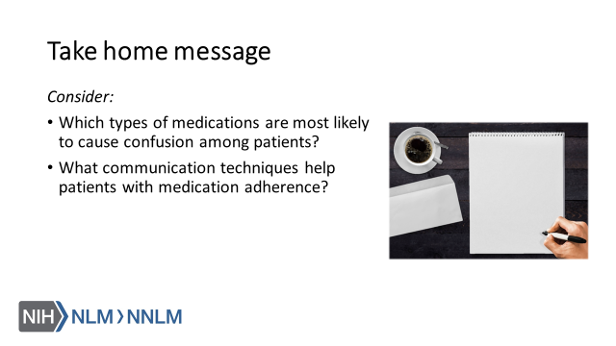

References:

- Soones, T., Lin, J., Wolf, M., O’Conor, M., Martynenko, M., Wisnivesky, J. & Federman, A. (2017). Pathways Linking Health Literacy, Health Beliefs, and Cognition to Medication Adherence in Older Adults with Asthma, 139(3), 804-809.
- Hersh, L., Salzman, B., Snyderman, D. (2015). Health Literacy in Primary Care Practice, American Family Physician, 92(2), 119-124.
- Miller, T. (2017). Health Literacy and Adherence to Medical Treatment in Chronic and Acute Illness: A Meta-Analysis. Patient Education and Counseling, 99(7), 1079-1086.
- U.S. Food and Drug Administration (2016). Why You Need to Take Your Medications as Prescribed or Instructed. Retrieved from URL to Source
- Ferdinand, K., Senatore, F., Clayton-Jeter, H., Cryer, D., Lewin, J., Nasser, S…Califf, R. (2017). Improving Medication Adherence in Cardiometabolic Disease: Practical and Regulatory Implications. Journal of the American College of Cardiology, 69(4), 437-451.

