Reflection of Values
- Reflection of Person: looking at your own personal beliefs, biases and values and the influences they may have on interactions¹
- Reflection of Profession: considering how a biomedical _________________ influences how you see the world¹
Building Relationships
- Building relationships can help a provider work in the “space between” their own values and the values of a patient³
Being Aware of Past and Present
- Consider how the ________________ of our country has contributed to current advantages and disadvantages²
Mindfulness
- Trying to avoid “auto-pilot” when busy²
- Looking at situations without a _____________²
- Responding to the current situation thoughtfully²
5R’s of Cultural Humility
- Reflection. “What did I ____________ from each person in that encounter?” ¹⁰
- Respect. “Did I treat everyone involved in that encounter respectfully?” ¹⁰
- Regard. “Did unconscious _____________ drive this interaction?” ¹⁰
- Relevance. “How was ____________________ relevant in this encounter?” ¹⁰
- Resiliency. “How was my personal resiliency affected by this interaction?” ¹⁰

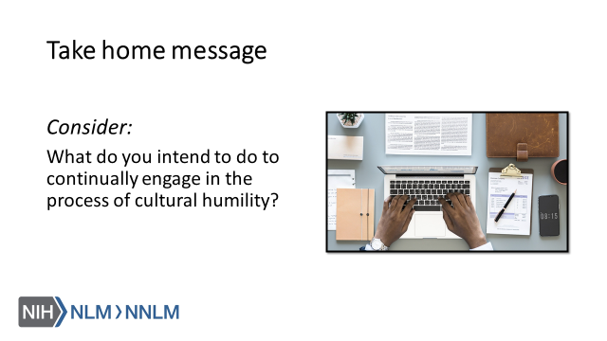

References:
- Fisher-Borne, M., Montana Cain, J. & Martin, S. (2015). From Mastery to Accountability: Cultural Humility as an Alternative to Cultural Competence. Social Work Education, 34(2), 165-181.
- Yeager, K., Bauer-Wu, S. (2013). Cultural Humility: Essential Foundation for Clinical Researchers. Applied Nursing Research, 26(4).
- Hughes, V., Delva, S., Nkimbeng, M., Spaulding, E., Turkson-Ocran, R., Cudjoe…Han, H. (2018). Not Missing the Opportunity: Strategies to Promote Cultural Humility Among Future Nursing Faculty, Journal of Professional Nursing, URL to Source
- Masters, C., Robinson, D., Faulkner, S., Patterson, E., McIlraith, T., Ansari, A. (2019). Addressing Biases in Patient Care with the 5Rs of Cultural Humility, a Clinician Coaching Tool. Journal of General Infernal Medicine, 34(4), 627-630.
- Kleinman, A. & Benson, P. (2006). Anthropology in the Clinic: The Problem of Cultural Competency and How to Fix It. Plos Med 3(10): e294.
- Drexel Dornsife School of Public Health (2016). Achieving Health Equity: Tools for a National Conversation on Racism, 2016 Jonathon Mann Health and Human Rights Memorial Lecture, APHA President and Noted Scholar Camara Jones Wants to Talk – and She’s Got Stories to Tell. Retrieved from: URL to Source
- Byrne, A. & Tanesini, A. (2015). Instilling New Habits: Addressing Implicit Bias in Healthcare Professionals. Advances in Health Sciences Education, 20, 1255-1262.
- White, A. & Stubblefield-Tave, B. (2017). Some Advice for Physicians and Other Clinicians Treating Minorities, Women, and other Patients at Risk of Receiving Health Care Disparities. Journal of Racial and Ethnic Health Disparities, 4, 472-479.
- Napier, D., Ancarno, C., Butler, B., Calabrese, J., Chater, A., Chaterjee, H… Guesnet, F. (2014). Culture and Health. The Lancet, 384, 1607-1639.
- Masters, C., Robinson, D., Faulker, S., Patterson, E., McIlraith, T., Ansari, A. (2018). Addressing Biases in Patient Care with the 5Rs of Cultural Humility, a Clinician Coaching Tool.

