Health Disparities

Mental Health
40% of transgender respondents have attempted suicide at some point in their lives compared to 4.6% of the population.

Substance Abuse
Some studies show that gay men use substances at higher rates than the general population

Cancer
Gay men are at higher risk for anal cancer.

Affirmative Interactions

They/Them/Theirs are acceptable singular pronouns.

Ask them what they call their body and mirror that language.

Include pronouns on your name tag and in your email signature, as well as on each of the staff biographies on your website.

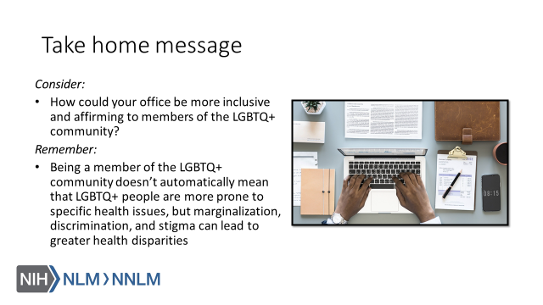

References:

- Substance Abuse and Mental Health Services Administration, Top Health Issues for LGBT Populations Information & Resource Kit. HHS Publication No. (SMA) 12-4684. Rockville, MD: Substance Abuse and Mental Health Services Administration, 2012.
- James, S. E., Herman, J. L., Rankin, S., Keisling, M., Mottet, L., & Anafi, M. (2016). The Report of the 2015 U.S. Transgender Survey. Washington, DC: National Center for Transgender Equality.
- Ashbee, Olivia, and Joshua Mira Goldberg. “Trans People and Cancer.” LGBT Cancer Information, National LGBT Cancer Network, 2019, http://cancer-network.org/wp-content/uploads/2017/02/Trans_people_and_cancer.pdf

