Cultural Competence Critiques
- Focuses on the ‘Other’
- Uses Culture as a Proxy
- Implies a ‘finite’ Learning Model³

Cultural Competence Criticisms
“…socioeconomic status produces its own cultures of security and insecurity that cut across nationality, ethnic background, gender orientation, age, and political persuasion. Socioeconomic status produces new cultures defined by degrees of social security and limitations on choice that privilege some people and disadvantage others.”⁸

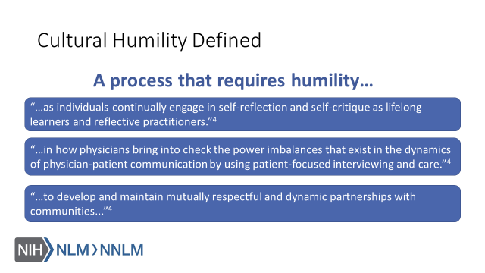

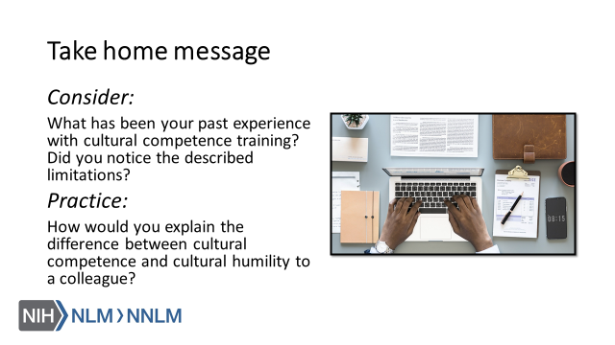

References:
- DeAngelis, T. (2015). In Search of Cultural Competence, Monitor on Psychology, 46(3), Retrieved from URL to source
- Fisher-Borne, M., Cain, J.M., & Martin, S.L. (2015). From Mastery to Accountability: Cultural Humility as an Alternative to Cultural Competence. Social Work Education, 34(2), 165-181. doi: 10.1080/02615479.2014.977244
- MacKenzie, L., Hatala, A (2019). Addressing culture within healthcare settings: the limits of cultural competence and the power of humility. Canadian Medical Education Journal, 10(1), e124-e127.
- Tervalon, M., Murray-Garcia, J. (1998). Cultural Humility Versus Cultural Competence: A Critical Distinction in Defining Physician Training Outcomes in Multicultural Education. Journal of Health Care for the Poor and Underserved, 9(2), 117-125.
- Malat, J. (2013). The Appeal and Problems of a Cultural Competence Approach to Reducing Racial Disparities. Journal of General Internal Medicine, 28(5), 605-607.
- White, A., Logghe, H., Goodenough, D., Barnes, L., Hallward, A., Allen, I… Llerena-Quinn, R. (2018). Self-Awareness and Cultural Identity as an Effort to Reduce Bias in Medicine. Journal of Racial and Ethnic Health Disparities, 5, 34-49.
- American Academy of Orthopaedic Surgeons (2009). Culturally Competent Care Guidebook. Retrieved from: URL to Source
- Napier, D., Ancarno, C., Butler, B., Calabrese, J., Chater, A., Chaterjee, H… Guesnet, F. (2014). Culture and Health. The Lancet, 384, 1607-1639.

