Health Disparities
“…differences that exist among specific population groups in the United States in the attainment of full health potential that can be measured by differences in incidence, prevalence, mortality, burden of disease, and other adverse health conditions”²
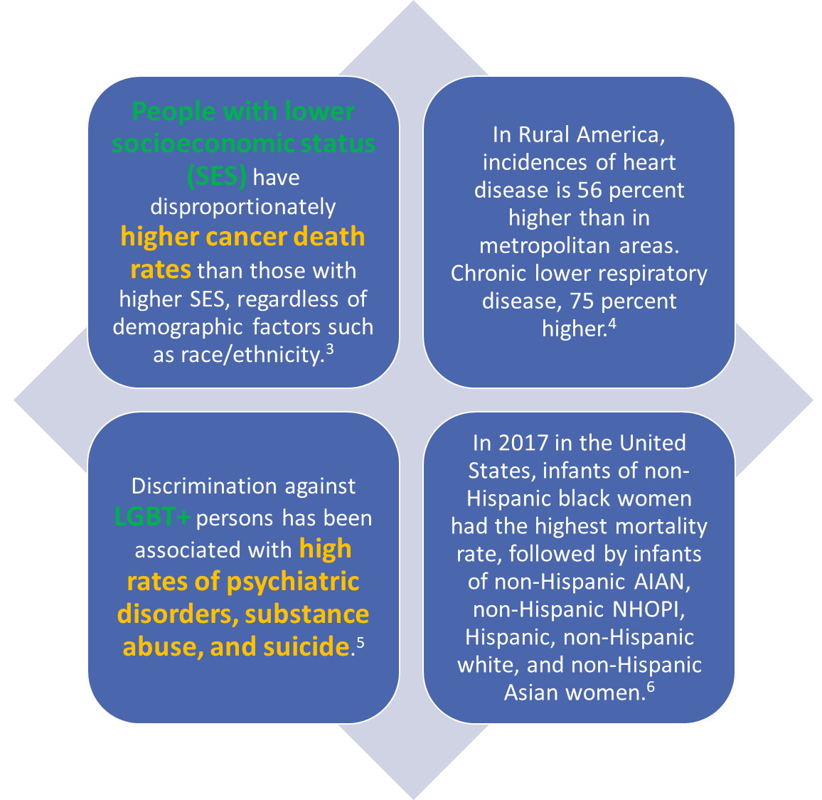
Examples of Health Disparities
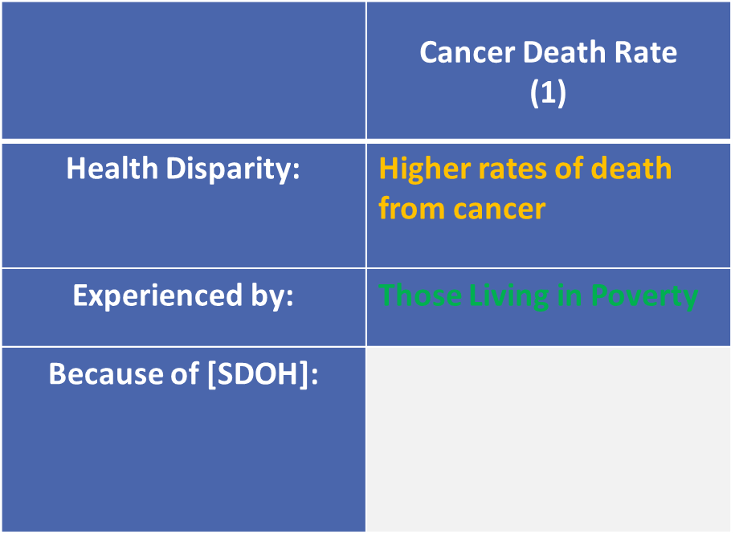

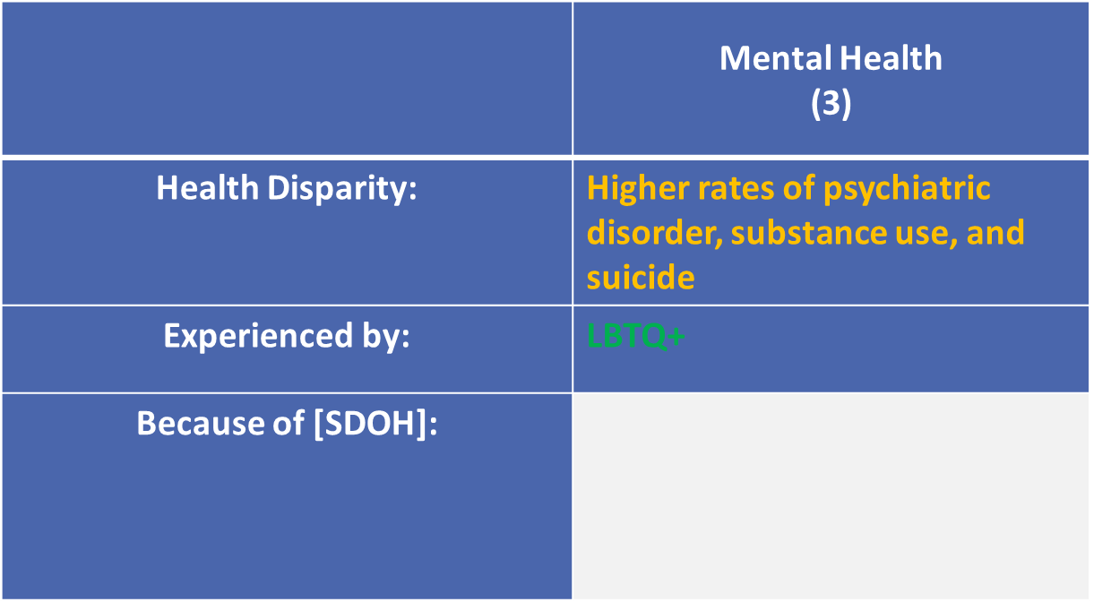

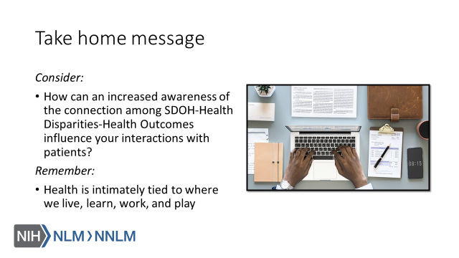

References
- The Root Causes of Health Inequity." National Academies of Sciences, Engineering, and Medicine. 2017. Communities in Action: Pathways to Health Equity. Washington, DC: The National Academies Press. doi: 10.17226/24624.U.S. Department of Health and Human Services, Healthy People 2020 Draft. 2009, U.S. Government Printing Office.
- National Academies of Sciences, Engineering, and Medicine; Health and Medicine Division; Board on Population Health and Public Health Practice; Committee on Community-Based Solutions to Promote Health Equity in the United States (2017). Baciu A., Negussie Y., Geller A., et al. (eds). Washington DC: National Academies Press.
- National Cancer Institute. 2019. Examples of Cancer Health Disparities. Available at: URL to Source
- Singh, GK et al. Widening Rural–Urban Disparities in Life Expectancy, U.S., 1969–2009. American Journal of Preventive Medicine, 2014;(46)2:19-29. doi: URL to Source
- Healthypeople.gov. 2019. Lesbian, Gay, Bisexual, and Transgender Health | Healthy People 2020. [online] Available at: URL to Source
- Centers for Disease Control and Prevention. 2019. Infant Mortality | Maternal and Infant Health | Reproductive Health | CDC. [online] Available at: URL to Source
- Boston Public Health Commission. 2019. Health Disparities vs. Health Inequities. Available at: URL to Source
- Child Trends Databank. 2015. Key facts about late or no prenatal care. Available at: URL to Source
- National Academies of Sciences, Engineering, and Medicine. 2017. “The State of Health Disparities in the United States.” Communities in Action: Pathways to Health Equity. Washington, DC: The National Academies Press. doi: 10.17226/24624. Available online at: URL to Source
- Pauly BM, Shahram SZ, Dang PTH, Marcellus L, MacDonald M. Health Equity Talk: Understandings of Health Equity among Health Leaders. AIMS Public Health. 2017;4(5):490–512. Published 2017 Nov 15. doi:10.3934/publichealth.2017.5.490
- U.S. Department of Health and Human Services (2019). Disparities. Retrieved from: URL to Source

