What is Precontemplation?

Precontemplation is the stage of when the patient is does not intend to make a change to their behavior in the next six months²

Precontemplation- what to do?
Someone may be in this stage because:
- Lack of information about risk
- Lack of self-confidence in changing³

Core principles + OARS for someone in precontemplation
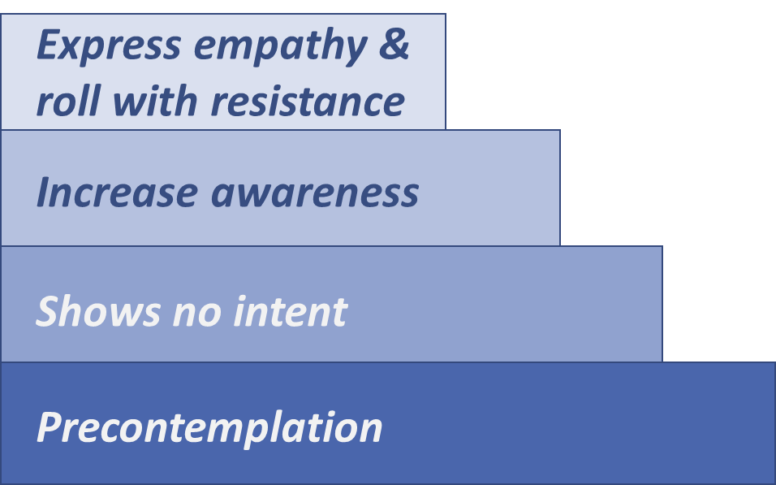
- Express empathy¹ using:
  - Affirmations⁴
  - Reflections^{4,5}
- Roll with resistance¹ using:
  - Reflections^{6,7}
Figure 1. Adapted from Tuccero, Railey, Briggs & Hull (2016). Behavioral Health in Prevention and Chronic Illness Management, Primary Care: Clinics in Office Practice, 43, 191-102. doi: 10.1016/j.pop.2016.01.006
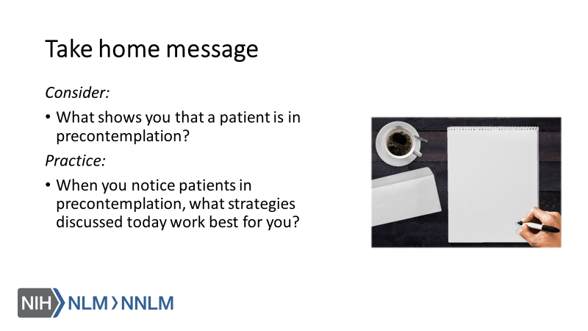

References:

- Tuccero, Railey, Briggs & Hull (2016). Behavioral Health in Prevention and Chronic Illness Management, Primary Care: Clinics in Office Practice, 43, 191-102. doi: 10.1016/j.pop.2016.01.006
- Glanz, K., Rimer, B. & Viswanath, K. (Eds.). (2015). Health Behavior: theory, research and practice. San Francisco: Jossey-Bass.
- Constance, A. & Sauter, C. (2011). Inspiring and Supporting Behavior Change. United States: American Dietetic Association.
- Gold, M., Kelly, T., Douihy, A. (2015). Motivational Interviewing: A Guide for Medical Trainees. New York: Oxford University Press.
- McGinnis P., Davis M., Howk S., DeSordi M. & Thomas M. (2014). Integrating Primary Care Practices and Community-based Resources to Manage Obesity: A Bridge-building Toolkit for Rural Primary Care Practice Transformation. Rockville, MD: Agency for Healthcare Research and Quality: AHRQ Publication No. 14-0043-EF. Retrieved from URL to source
- Rollnick, S., Miller, W., Butler, C. (2008). Motivational Interviewing in Healthcare. Guilford press: New York
- Dartmouth Psychiatric Research Center [Dartmouth]. 2009, August 6. Practice Demonstration Video - Motivational Counseling [video file]. Retrieved from URL to Source

