Hi everyone,
I look forward to touching base with you [tomorrow, on Wednesday, etc.] for our sixth health literacy Clinical Conversation. Here was the primary message from module 5.
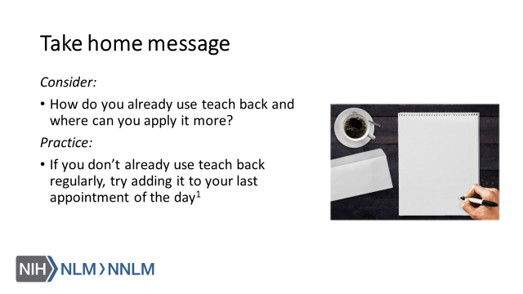

Reference:
Brega AG, Barnard J, Mabachi NM, Weiss BD, DeWalt DA, Brach C, Cifuentes M, Albright K, West, DR. (2015). AHRQ Health Literacy Universal Precautions Toolkit, Second Edition. (Prepared by Colorado Health Outcomes Program, University of Colorado Anschutz Medical Campus under Contract No. HHSA290200710008, TO#10.) AHRQ Publication No. 15-0023-EF. Rockville, MD. Agency for Healthcare Research and Quality. Retrieved from URL to Source

