What makes a research question effective?
It must be ____________ (each aspect of the question is specific) and ____________ (the question’s overall scope is narrow enough).

The PICO(T) Framework²:
P:
I:
C:
O:
T:
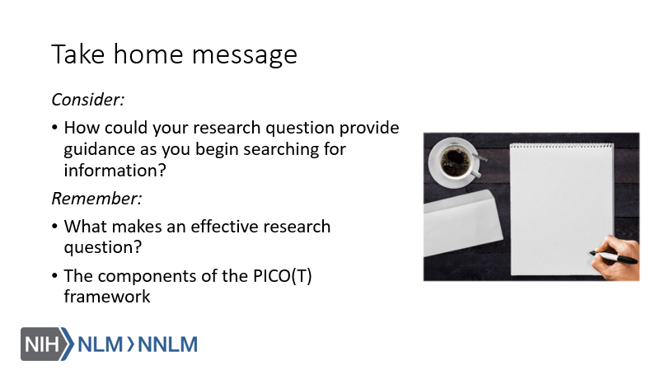

References
- Raich, A.L. & Skelly, A.C. (2013). Asking the right question: Specifying your study question. Evidence Based Spine Care, 4(2), 68-71. Retrieved from: URL to Source.
- Melnyk B., & Fineout-Overholt E. (2010). Evidence-based practice in nursing & healthcare. New York: Lippincott Williams & Wilkins.

