What is Shared Decision Making?
Shared Decision Making is “An approach where clinicians and patients share the best available evidence when faced with the task of making decisions, and when patients are supported to consider options, to achieve informed preferences¹”
Link to Evidence-Based Practice
The step of evidence-based practice of applying evidence to practice has always been linked to the spirit of shared decision making²
Shared decision making can be seen as one tool to accomplish evidence-based healthcare²
SDM- Evidence
Evidence shows that shared decision making:
- Increases patient satisfaction⁴
- Increases patient confidence¹
- Promotes knowledge gain and involvement¹
- Improves health outcomes⁴
- Decreases demand for health care resources⁴
Hypothetical cases (1)
“Katherine (age 67) had recently been diagnosed with breast cancer. She was widowed, living alone in a rural location and did not drive. She was offered a choice between lumpectomy with radiotherapy (breast conservation theory) or mastectomy and was told of the equal survival rates for the two procedures. She was surprised by this choice and became anxious. She listened to the advice, and although she was given good information, felt steered towards having a lumpectomy and radiotherapy as the “less invasive” option. She became very tired during the radiotherapy, and her breast became tender and much smaller, an effect that she did not anticipate. Two years later, an ipsilateral local recurrence of the breast cancer necessitated a mastectomy. At this point, she became aware that there was a higher (double) rate of local recurrence after lumpectomy. She felt regret and considered that her decision might have been different if she had been given more information and a chance to express her strong wish to avoid recurrence.”
Hypothetical cases (2)
“Edward (aged 75) had recently been diagnosed as having an enlarged prostate gland causing him bothersome urinary symptoms. He was offered surgery as the most effective treatment and accepted the recommendation. Before surgery, he enjoyed an active sex life, which was important to him and his wife, but this was seriously affected by the surgery. He had been made aware that some men have sexual problems after surgery, but he did not feel as if he’d had a chance to consider the extent of this risk or to consider whether this was a concern to him personally. Looking back, he feels that if he had been given more of a change to discuss his preferences, he may have postponed surgery in favor of ‘watchful waiting.’”1

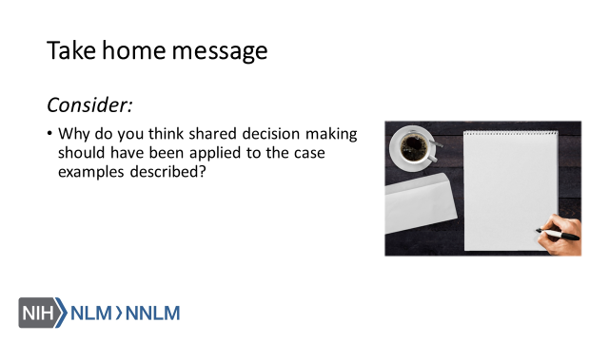

References:

- Elywn,G., Frosch, D., Thomson, R., Joseph-Williams, N., Lloyd, A., Kinnersley, P.,… Barry, M. (2012). Shared Decision Making: A Model for Clinical Practice, Journal of General Internal Medicine, 27(10), 1361-1367.
- Therialult, G., Bell, N., Grad, R., Singh, H. & Szafran, O. (2019). Teaching Shared Decision Making. Canadian Family Physician, 65, 514-516.
- Legare, F. & Thompson-Leduc, P. (2014). Twelve Myths About Shared Decision Making. Patient Education and Counseling, 96, 281-286.
- Agency for Healthcare Research and Quality (2019). The CAHPS Ambulatory Care Improvement Guide: Practical Strategies for Improving Patient Experience. URL to Source
- Agency for Healthcare Research and Quality (2018). The SHARE Approach. URL to Source

