Teach Back
Teach back is a way of checking a patient’s understanding of information by asking them to state what they heard in their ________________¹.
The benefits of using this include:
- Better understanding and _________________.
- Improved _____________ and outcomes
- Reduction in callbacks and canceled appointments¹
Implementation tips:
- Not a test of the patient’s knowledge
- ___________ your approach
- “______________ and Check”
- Clarify and check again
- Start slowly and use consistently
- Practice¹
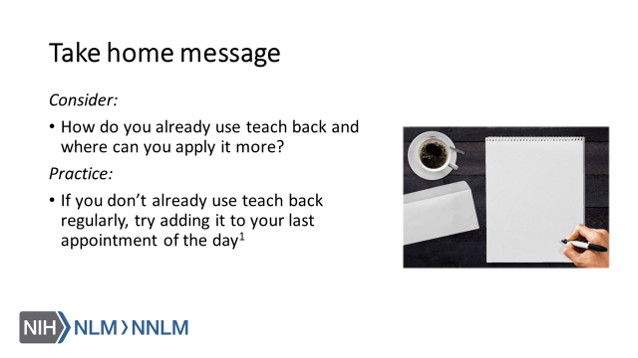
References:
- Brega AG, Barnard J, Mabachi NM, Weiss BD, DeWalt DA, Brach C, Cifuentes M, Albright K, West, DR. (2015). AHRQ Health Literacy Universal Precautions Toolkit, Second Edition. (Prepared by Colorado Health Outcomes Program, University of Colorado Anschutz Medical Campus under Contract No. HHSA290200710008, TO#10.) AHRQ Publication No. 15-0023-EF. Rockville, MD. Agency for Healthcare Research and Quality. Retrieved from URL to Source
- Trina, D. (2016). Use the Teach-Back Method to Confirm Patient Understanding. The Hospitalist. 2016(6). Retrieved from: URL to Source

