Hi Everyone,

Thank you for attending our third conversation about the social determinants of health. Here was the main take home point from this module.
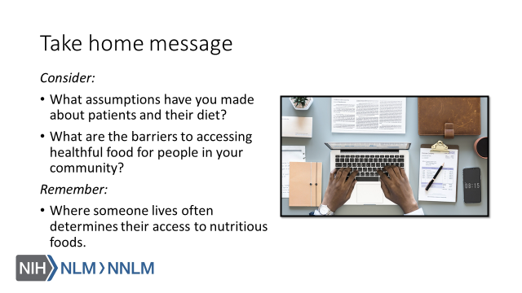

Thank you,

