Important Points About Culture
- Cultures can merge and change^{2,3}
- Cultural values may be expressed more or less in different circumstances²
- Culture is linked to condition that surround a person, such as the economy and politics³
- Culture is not only a persons’ race or ethnicity^{2,3}

Profession and Culture
“The cross-cultural reality is that even a patient who matches [their] doctor on age, gender, race, and native language will differ on other cultural dimensions. These could be family status, national origin, sexual orientation, and profession”⁴

Power & Privilege Wheel
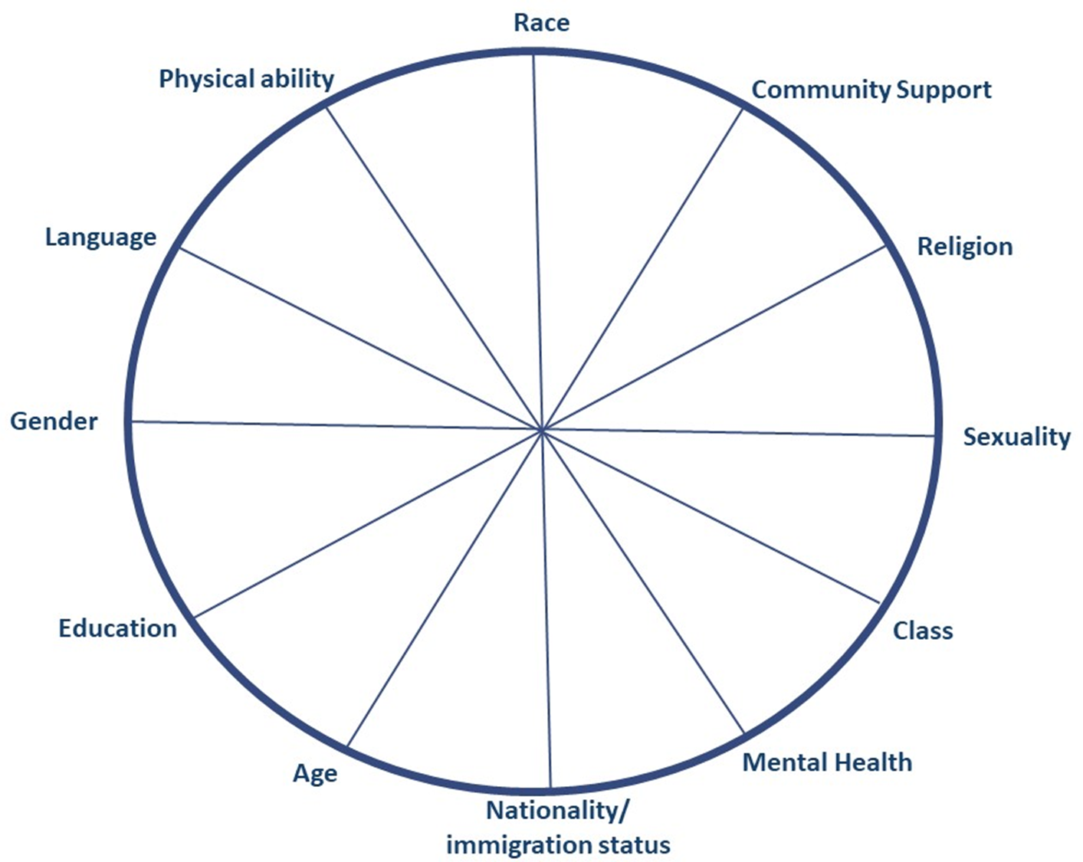

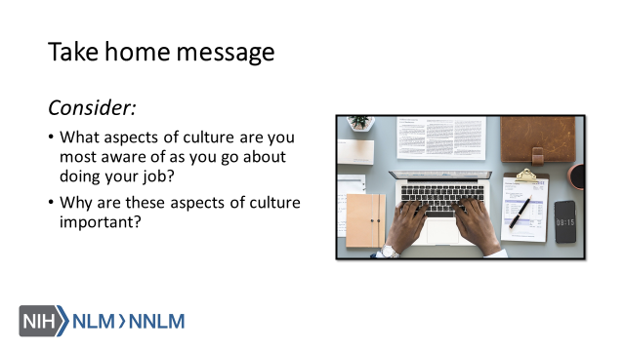

References:
- MacKenzie, L., Hatala, A (2019). Addressing culture within healthcare settings: the limits of cultural competence and the power of humility. Canadian Medical Education Journal, 10(1), e124-e127.
- Napier, D., Ancarno, C., Butler, B., Calabrese, J., Chater, A., Chaterjee, H… Guesnet, F. (2014). Culture and Health. The Lancet, 384, 1607-1639.
- Kleinman, A. & Benson, P. (2006). Anthropology in the Clinic: The Problem of Cultural Competency and How to Fix It. Plos Med 3(10): e294.
- White, A. & Stubblefield-Tave, B. (2017). Some Advice for Physicians and Other Clinicians Treating Minorities, Women, and other Patients at Risk of Receiving Health Care Disparities. Journal of Racial and Ethnic Health Disparities, 4, 472-479.
- Kim, S. and Andrews, N. Privilege and Identity Wheel. 2017. URL to source

