Hello everyone,
In our Clinical Conversation [last week, on Wednesday, etc.] we talked about the difference between readability, plain language, and health literacy. Here is a short newsletter article about these concepts to look over when you have a few minutes.
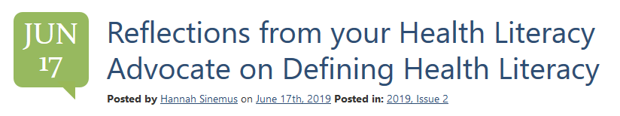
Click the title to be redirected to the NNLM MAR quarterly newsletter, the MAR Report.

