Motivational Interviewing
“Motivational Interviewing is a collaborative, patient centered form of guiding to elicit and strengthen the motivation to change.”¹
Ambivalence
Ambivalence is a central concept to motivational interviewing^{2,8}. This is when a person has positive and negative feelings about change⁵ and isn’t sure which choice to make⁹.
Motivational interviewing can help someone work through ambivalence^{2,8}.
The Spirit of Motivational Interviewing
The spirit of Motivational interviewing can be outlined with four concepts⁵:

  - Partnership
  - Acceptance
  - Compassion
  - Evocation
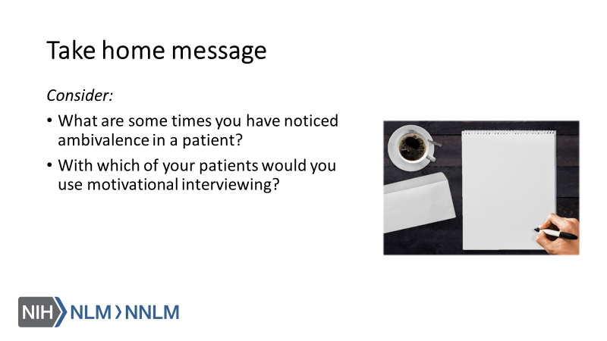

References:

- Tuccero, Railey, Briggs & Hull (2016). Behavioral Health in Prevention and Chronic Illness Management, Primary Care: Clinics in Office Practice, 43, 191-102. doi: 10.1016/j.pop.2016.01.006
- Kelley, C., Sbrocco, G., and Sbrocco, T. (2016). Behavioral Modification for the Management of Obesity, Primary Care, 43(1), 159-175. doi: 10.1016/j.pop2015.10.004
- Office of the Legislative Council (2010). Compilation of the Patient Protection and Affordable Care Act. Retrieved from URL to source
- Centers for Disease Control and Prevention (2016). Chronic Diseases in America. Retrieved from: URL to source
- Gold, M., Kelly, T., Douihy, A. (2015). Motivational Interviewing : A Guide for Medical Trainees. New York: Oxford University Press.
- Lundahl, B., Moleni, T., Burke, B., Butters, R., Tollefson, D., Butler, C. & Rollnick, S. (2013). Motivational Interviewing in Medical Care Settings: A Systematic Review and Meta-Analysis of Randomized Controlled Trials, 93, 157-168.
- VanBuskirk, K. & Loebach Wetherell, J. (2014). Motivational Interviewing Used in Primary Care A Systematic Review and Meta-analysis, 37(4), 768-780.
- Britt, E., Hudson, S. & Blampied, N. (2003). Motivational Interviewing in Health Settings: A Review, 53, 147-155.
- Constance, A. & Sauter, C. (2011). Inspiring and Supporting Behavior Change. United States: American Dietetic Association.
- Oh, H. & Lee, C. (2016). Culture and Motivational Interviewing, Patient Education and Counseling, 99(11), 1914-1919. doi:10.1016/j.pec.2016.06.010
- Rollnick, S., Miller, W. & Butler, C. (2008). Motivational Interviewing in Healthcare. New York: Guilford Press.
- Miller, T. (2016). Health Literacy and Adherence to Medical Treatment in Chronic and Acute Illness: A Meta-Analysis, 99(7), 1079-1086.

