Step 1: Seek your Patient’s Participation²
AHRQ SHARE Curriculum teaches 5 steps that are suggested in the process of shared decision making:

- Summarize the issue^{1,2}
- Let them know there are different options^{1,2}
- Discuss the importance of participation^{1,2}
- Consider including caregivers/ family²
Step 2: Help your Patient Explore and Compare Treatment Options²
- Check current knowledge^{1,2}
- List options^{1,2}
- Describe options clearly^{1,2}
- Use decision tools^{1,2}, when available²
- Summarize^{1,2} and check for understanding (teach back)²
Step 3: Assess your Patient’s Values and Preferences²
- Encourage thinking about what is most important^{1,2}
- Elicit a preference¹
  - Open ended questions²
  - Active listening²
  - Empathy²
- Acknowledge their values and preferences²
Step 4: Reach a Decision with your Patient²
- Ask if they are ready to decide^{1,2}
- Ask if they need more time or more information^{1,2}
- Confirm the decision²
- Schedule necessary follow up²
Step 5: Evaluate your Patient’s Decision²
- Consider how well the treatment is implemented²
- Assist the patient with overcoming barriers to following their treatment decision²
- Revisit the decision to discuss other possible decisions²

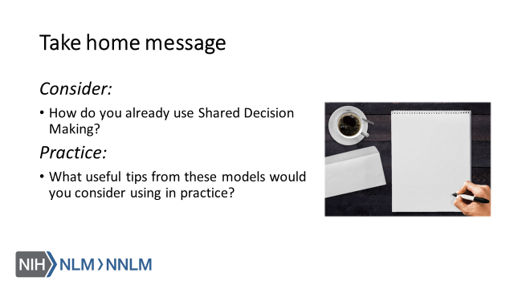

References
- Elywn,G., Frosch, D., Thomson, R., Joseph-Williams, N., Lloyd, A., Kinnersley, P.,… Barry, M. (2012). Shared Decision Making: A Model for Clinical Practice, Journal of General Internal Medicine, 27(10), 1361-1367.
- Agency for Healthcare Research and Quality (2018). The SHARE Approach. Retrieved from URL to Source

