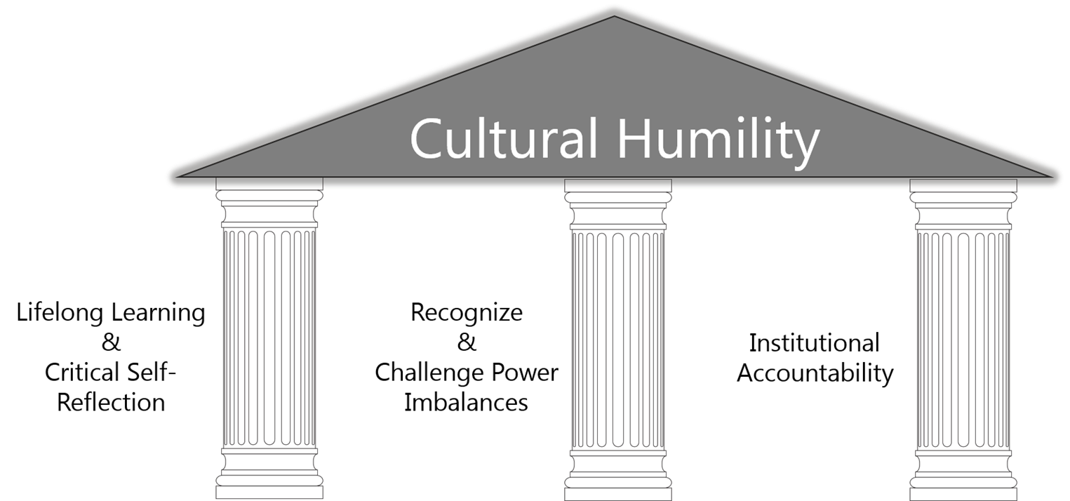

Fig 1 Tervalon, M. & Murray-Garcia, J. (1998). Cultural Humility Versus Cultural Competence: A Critical Distinction in Defining Physician Training Education Outcomes in Multicultural Education. Journal of Health Care for the Poor and Underserved, 9(2), 117-125.

Cultural humility follows three principles:
- Lifelong learning and critical self-reflection.
  - How does your Cultural Background affect reactions to and interactions with patients? ²
  - Avoid being an “expert” in a culture and learn from the patient ^{1,3}
- Recognize and challenge power imbalances.
  - “Every clinical encounter is a cross cultural encounter”⁵
  - “What social and economic barriers impact a client’s ability to receive effective care?”²
- Institutional Accountability.
  - Diversity of staff and leadership^{1,2}
  - Discussion about oppression and inclusion^{1,2}
  - Training to encourage self-reflection²

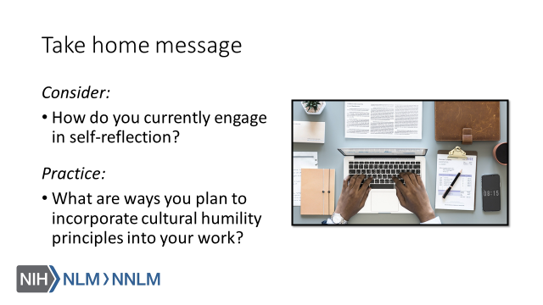

References:
- Tervalon, M. & Murray-Garcia, J. (1998). Cultural Humility Versus Cultural Competence: A Critical Distinction in Defining Physician Training Education Outcomes in Multicultural Education. Journal of Health Care for the Poor and Underserved, 9(2), 117-125
- Fisher-Borne, M., Montana Cain, J. & Martin, S. (2015). From Mastery to Accountability: Cultural Humility as an Alternative to Cultural Competence. Social Work Education, 34(2), 165-181.
- MacKenzie, L., Hatala, A (2019). Addressing culture within healthcare settings: the limits of cultural competence and the power of humility. Canadian Medical Education Journal, 10(1), e124-e127.
- Kleinman, A. & Benson, P. (2006). Anthropology in the Clinic: The Problem of Cultural Competency and How to Fix It. Plos Med 3(10): e294.
- White, A. & Stubblefield-Tave, B. (2017). Some Advice for Physicians and Other Clinicians Treating Minorities, Women, and other Patients at Risk of Receiving Health Care Disparities. Journal of Racial and Ethnic Health Disparities, 4, 472-479.

