Hi Everyone,

Thank you for your coming to our final conversation on cultural humility. Here was the final take home point.

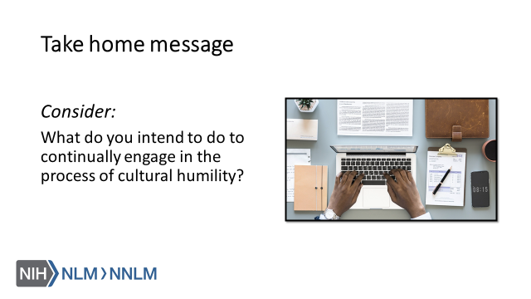

Thank you,

