Hi Everyone,

Thank you for attending our third conversation about the social determinants of health, which focused on food insecurity. In this module, we talked about food insecurity. In this module, there was discussion about the data map from Feeding America. If you are interested in this tool, you can click the map below.

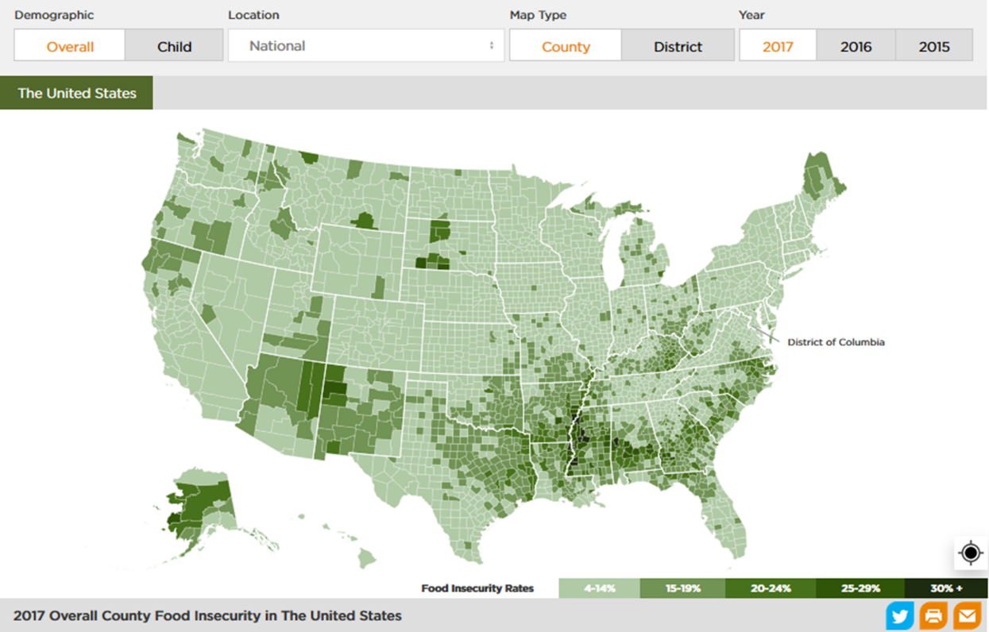

Thank you,

