Evidence Types
There are many different types of evidence you might consult to answer a research question: background information (e.g., ________________), expert opinion, _______ _____________ and studies, cohort studies, non-randomized and randomized __________________ ______________, critically appraised literature and evidence-based guidelines, and _______________ _______________ & meta-analyses.
The Evidence Pyramid³
These can be organized into a hierarchy of general reliability³:
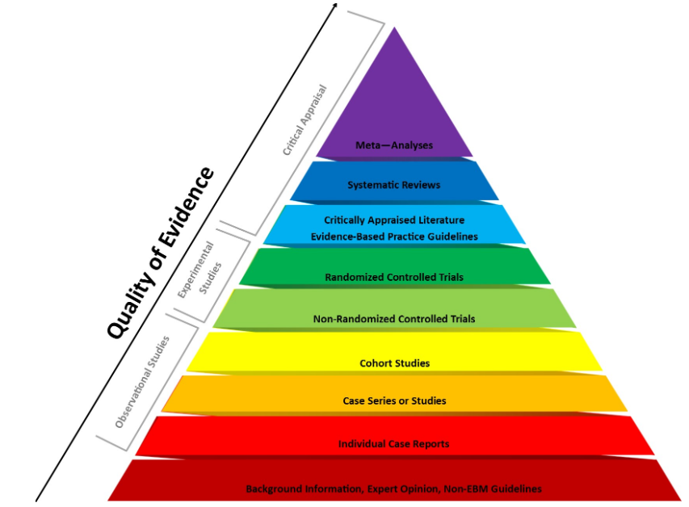

Fig 1. This image was produced by Bradley A. Long and Audrey Rock, Central Michigan University Libraries (©2016). The image is based on the EBM Page Generator from Dartmouth College and Yale University (©2006) and the Coursera MOOC “Understanding Clinical Research: Behind the Statistics” (©2016).

The Evidence Pyramid³
The pyramid from critically appraised literature up is considered ______________ information because someone has already assessed the quality of studies. The rest of the pyramid is considered ________________ information and you will need to critically appraise the quality of articles before relying on them for information.

Systematic reviews and meta-analyses (top of the pyramid) are considered the _____________________ of evidence as they collect, summarize, and analyze all other empirical evidence about a topic.

Study Design & Study Topic⁴
You should also consider what type of evidence is best-suited to answer your question:
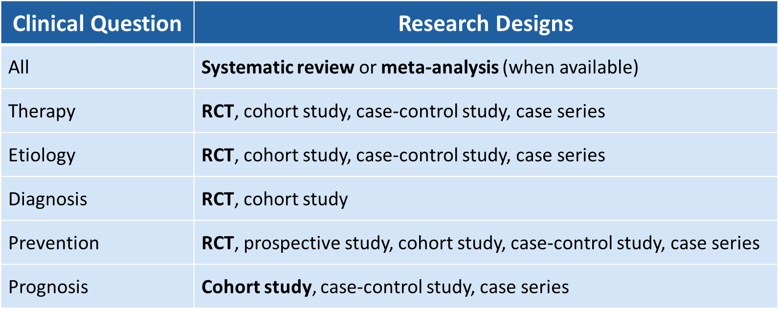

References
- Porcino, A.H. (2016). Not birds of a feather: Case reports, case studies, and single-subject research. International Journal of Therapeutic Massage & Bodywork, 9(3), 1-2.
- Study design 101. (n.d.). Retrieved from URL to Source
- Evidence-based medicine: Resources by levels of evidence. (n.d.). Retrieved from URL To Source
- Evidence-based practice toolkit. (n.d.) Retrieved from URL to Source

