Greeting of Your Choice,

Thank you for whatever they did or message of your creation…

Because increasing membership enhances partnerships and helps us all do more good together, please help spread the word about NNLM Region 1 by forwarding the membership invitation at the bottom of this email to as many contacts as you wish (to the other branches in your system, satellite or other campuses, colleagues, community groups, listservs or individuals – all are welcome).

More members = more partnerships = healthier communities!

Thanks again for your important role with the Network of the National Library of Medicine (NNLM), Region 1! We value your support and participation and look forward to future collaborations.

Best wishes,

Your Signature

______________________________________________________________

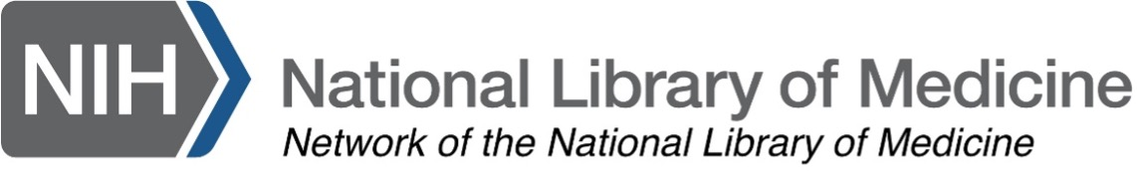

Join NNLM Region 1!

We are the Network of the National Library of Medicine (NNLM), a collaborative group of libraries and other organizations dedicated to improving the health literacy of our communities through promotion of reliable health information resources and instruction on how to use them. We serve everyone from all spectrums of health care and health education. Membership and all services are FREE!

NNLM is the outreach arm of the National Library of Medicine (NLM) and is divided into 7 regions across the country. We are the Region 1 and we serve these states and territories:

District of Columbia, Delaware, Kentucky, Maryland, New Jersey, North Carolina, Pennsylvania, Virginia and West Virginia

[If you’re from another state, find your regional contacts here.]

Complete an Organizational Member Application and join us in the fight against health disparities. As part of your free membership, you can:

- Apply for any of our grant funding awards when they are available to attend a conference, bring in a speaker, host a health fair, conduct health information outreach in your community and much more!

- Attend free classes* on a variety of health information topics and resources.

*Our free CE classes support several Medical Library Association (MLA) Specializations! (Consumer Health, Data, Disaster, Health Education)

- Reserve an NLM Traveling Exhibit to engage your community and/or complement your programming. Themes from The History of Medicine to the Potions of Harry Potter to Medical Careers to Frankenstein and Forensic Medicine are a few possibilities! (Use our funding to pay shipping fees!)

- Host a Reading Club – the NNLM Reading Club is a selection of “ready to use” book titles, provided with free and downloadable materials, designed to help you support the health information needs in your community.

- Keep up on regional and NLM news and updates, including funding announcements from NNLM and NLM and keep informed as a subscriber to ROI: Region One Insights, the NNLM Region 1 blog. You can even contribute to the blog - Just let us know if you’re interested!

- Network with other members to form partnerships, share expertise or just enjoy connecting with colleagues!

We’d love to welcome you to the network – Please reach out and let me know how we can be of assistance to you and your community.

Join us – as an individual or as an organization!

Individual User Account (enables individuals to take free classes, but no other member benefits)

Organizational Membership (Step One: Create an individual user account and login to nnlm.gov.)

Wishing you healthy & happy communities,

Nancy

Nancy Patterson, MLS
Outreach Librarian
NNLM, Region 1
University of Maryland, Baltimore
Health Sciences & Human Services Library
601 West Lombard Street
Baltimore MD 21201
Email: npatters@hshsl.umaryland.edu

