Evidence Types
There are many different types of evidence you might consult to answer a research question: background information (e.g., textbooks), expert opinion, case reports and studies, cohort studies, non-randomized and randomized controlled trials, critically appraised literature and evidence-based guidelines, and systematic reviews & meta-analyses.
The Evidence Pyramid³
These can be organized into a hierarchy of general reliability³:
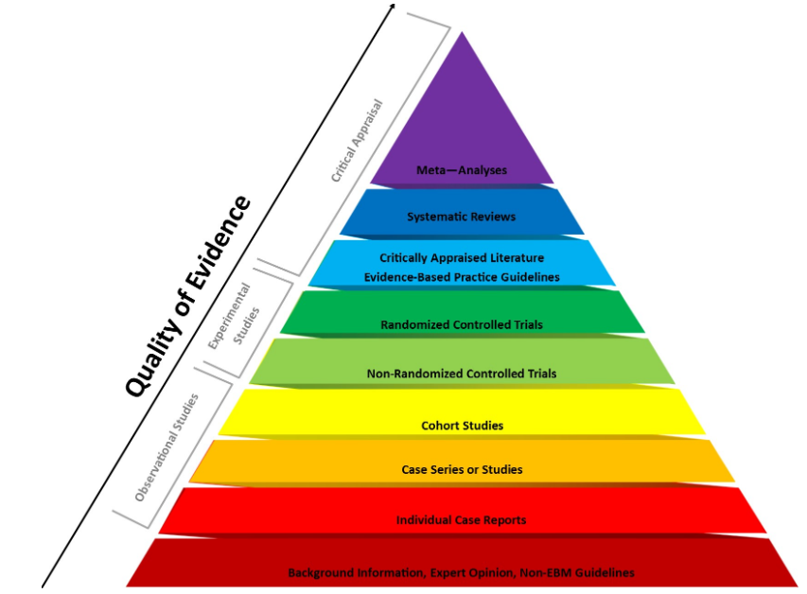
Fig 1. This image was produced by Bradley A. Long and Audrey Rock, Central Michigan University Libraries (©2016). The image is based on the EBM Page Generator from Dartmouth College and Yale University (©2006) and the Coursera MOOC “Understanding Clinical Research: Behind the Statistics” (©2016).

The Evidence Pyramid³
The pyramid from critically appraised literature up is considered filtered information because someone has already assessed the quality of studies. The rest of the pyramid is considered unfiltered information and you will need to critically appraise the quality of articles before relying on them for information.

Systematic reviews and meta-analyses (top of the pyramid) are considered the gold standard of evidence as they collect, summarize, and analyze all other empirical evidence about a topic.

Study Design & Study Topic⁴
You should also consider what type of evidence is best-suited to answer your question:
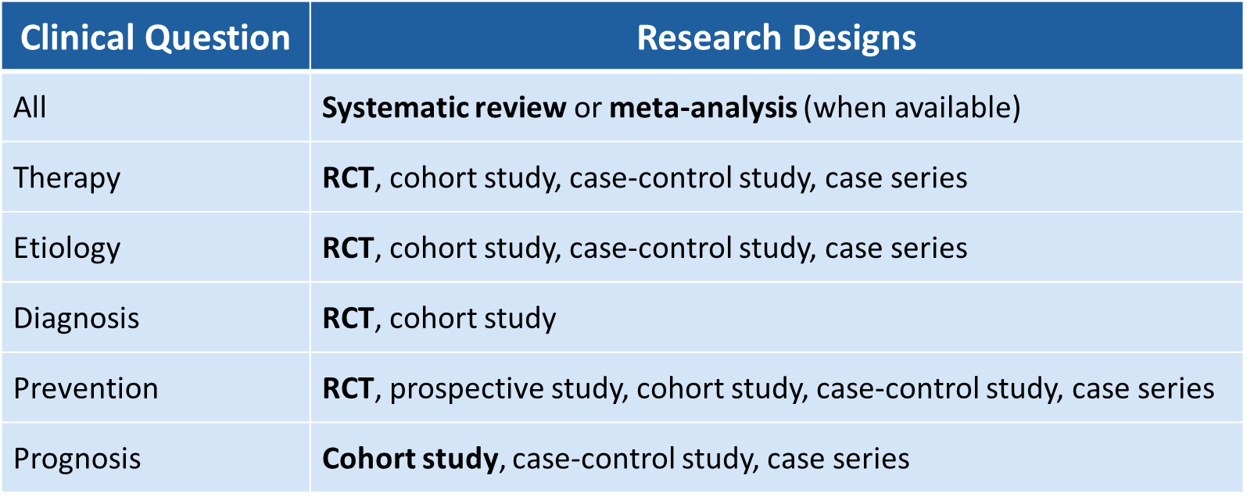

References
- Porcino, A.H. (2016). Not birds of a feather: Case reports, case studies, and single-subject research. International Journal of Therapeutic Massage & Bodywork, 9(3), 1-2.
- Study design 101. (n.d.). Retrieved from URL to Source
- Evidence-based medicine: Resources by levels of evidence. (n.d.). Retrieved from URL To Source
- Evidence-based practice toolkit. (n.d.) Retrieved from URL to Source

