Hi Everyone,

Thank you for your attendance at our second cultural humility module within Clinical Conversations. In this conversation, we discussed culture and health. Included here is the power and privilege wheel that was on one of the slides. Reflecting on your own values is part of cultural humility, so when you have a chance, it is worth looking over this and thinking about where you would place yourself on this wheel. If you are more privileged on a certain aspect of your personal identity, you’d place yourself closer to the center of the wheel. Something else to think about- are there pieces of your identity that are important to you that are not included here?

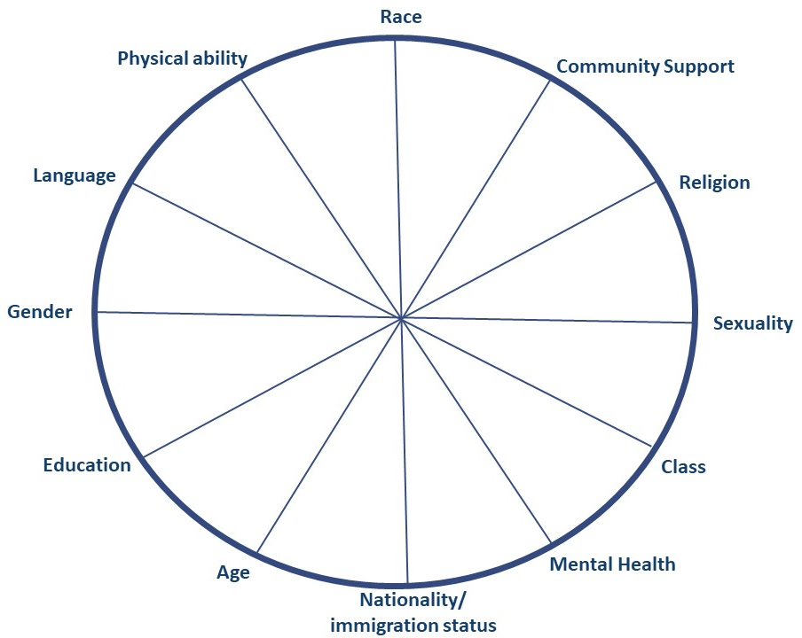

Fig 1. Sunny Kim and Nicole Andrews, 2017

Thank you,

