What are Maintenance and Relapse?
Maintenance: has been successful at behavior change for at least ___________________^{2,3}
Relapse: Not a stage in itself, but a return to one of the ______________________⁸

Core principles + OARS for someone in Maintenance
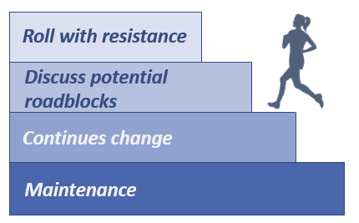
- Help them consider possible ______________ and plan ahead for them^{3,1}
- Roll with resistance¹
  - Affirmations⁴

Figure 1. Adapted from Tuccero, Railey, Briggs & Hull (2016). Behavioral Health in Prevention and Chronic Illness Management, Primary Care: Clinics in Office Practice, 43, 191-102. doi: 10.1016/j.pop.2016.01.006

Core principles + OARS for someone in Relapse
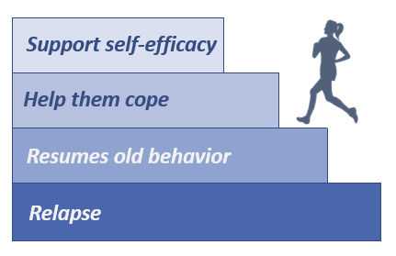
- Help them decide how they would like to proceed³
- Identify what ____________they seem to be in and address them in this way
- Support ______________¹
  - Affirmations⁴
Figure 2. Adapted from Tuccero, Railey, Briggs & Hull (2016). Behavioral Health in Prevention and Chronic Illness Management, Primary Care: Clinics in Office Practice, 43, 191-102. doi: 10.1016/j.pop.2016.01.006
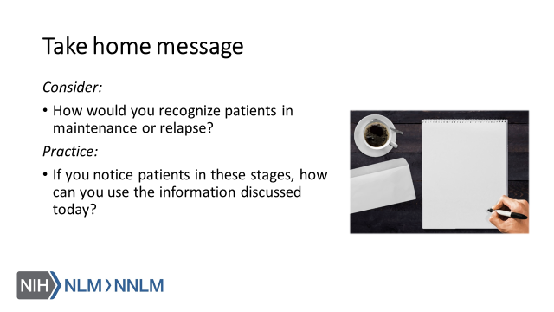

References:

- Tuccero, Railey, Briggs & Hull (2016). Behavioral Health in Prevention and Chronic Illness Management, Primary Care: Clinics in Office Practice, 43, 191-102. doi: 10.1016/j.pop.2016.01.006
- Glanz, K., Rimer, B. & Viswanath, K. (Eds.). (2015). Health Behavior: theory, research and practice. San Francisco: Jossey-Bass.
- Constance, A. & Sauter, C. (2011). Inspiring and Supporting Behavior Change. United States: American Dietetic Association.
- Gold, M., Kelly, T., Douihy, A. (2015). Motivational Interviewing : A Guide for Medical Trainees. New York: Oxford University Press.
- McGinnis P., Davis M., Howk S., DeSordi M. & Thomas M. (2014). Integrating Primary Care Practices and Community-based Resources to Manage Obesity: A Bridge-building Toolkit for Rural Primary Care Practice Transformation. Rockville, MD: Agency for Healthcare Research and Quality: AHRQ Publication No. 14-0043-EF. Retrieved from URL to source
- Stewart, E., Taylor-Post, N., Nichols L., Staton E., & Schleuning A. (2014). Community Connections: Linking Primary Care Patients to Local Resources for Better Management of Obesity. Rockville, MD: Agency for Healthcare Research and Quality; AHRQ Publication No. 14-0030-EF. Retrieved from URL to Source
- Center for Substance Abuse Treatment (1999). Enhancing Motivation for Change in Substance Abuse Treatment. Treatment Improvement Protocol (TIP) Series, No. 35. HHS Publication No. (SMA) 12-4212. Rockville, MD: Substance Abuse and Mental Health Services Administration. Retrieved from URL to Source
- Prochaska, J. (1997). The Transtheoretical Model of Health Behavior Change. American Journal of Public Health, 12(1), 38-48.

