Hi everyone,
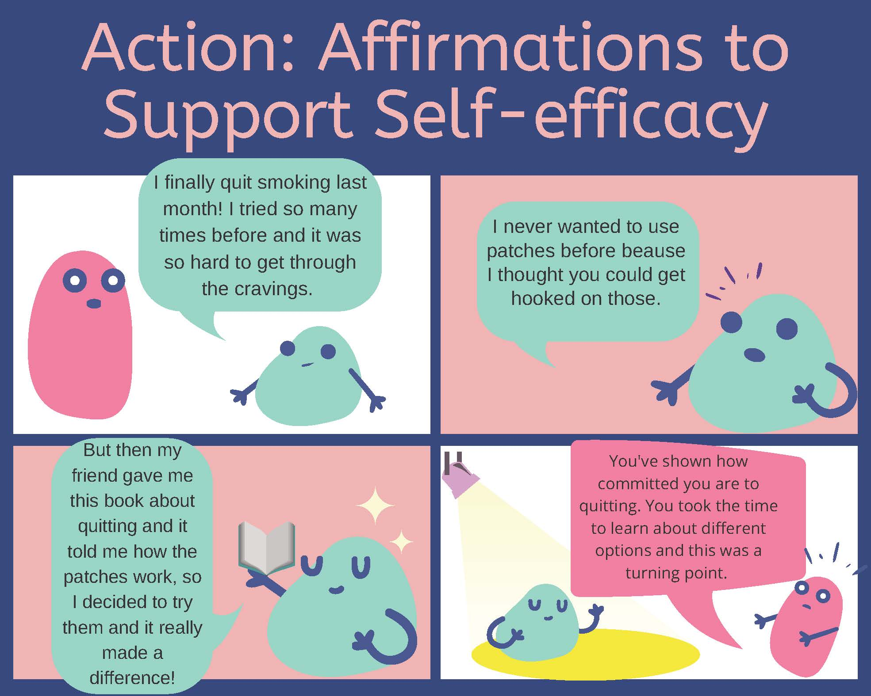
Thank you for attending our seventh Clinical Conversation about MI and the action stage. During this conversation, we discussed different MI strategies for working with someone in action. One of these was using affirmations to support self-efficacy¹. Here is a quick example of what this could look like.
Interested in more information about comics in healthcare? Check out NNLM’s education & information page about Graphic Medicine.

References:
- Gold, M., Kelly, T., Douihy, A. (2015). Motivational Interviewing: A Guide for Medical Trainees. New York: Oxford University Press

