In the Transgender module, we discussed how gender and sex are spectrums. We also discussed how everyone has a gender expression, gender identity, sexual orientation, and biological sex, not just people who are transgender. Using the image below, think about your own gender and sex and place an X on each of the lines below where you think you belong on the spectrum. You don’t have to share this with anyone else and it can remain anonymous. How did you decide where you placed yourself on these spectrums?

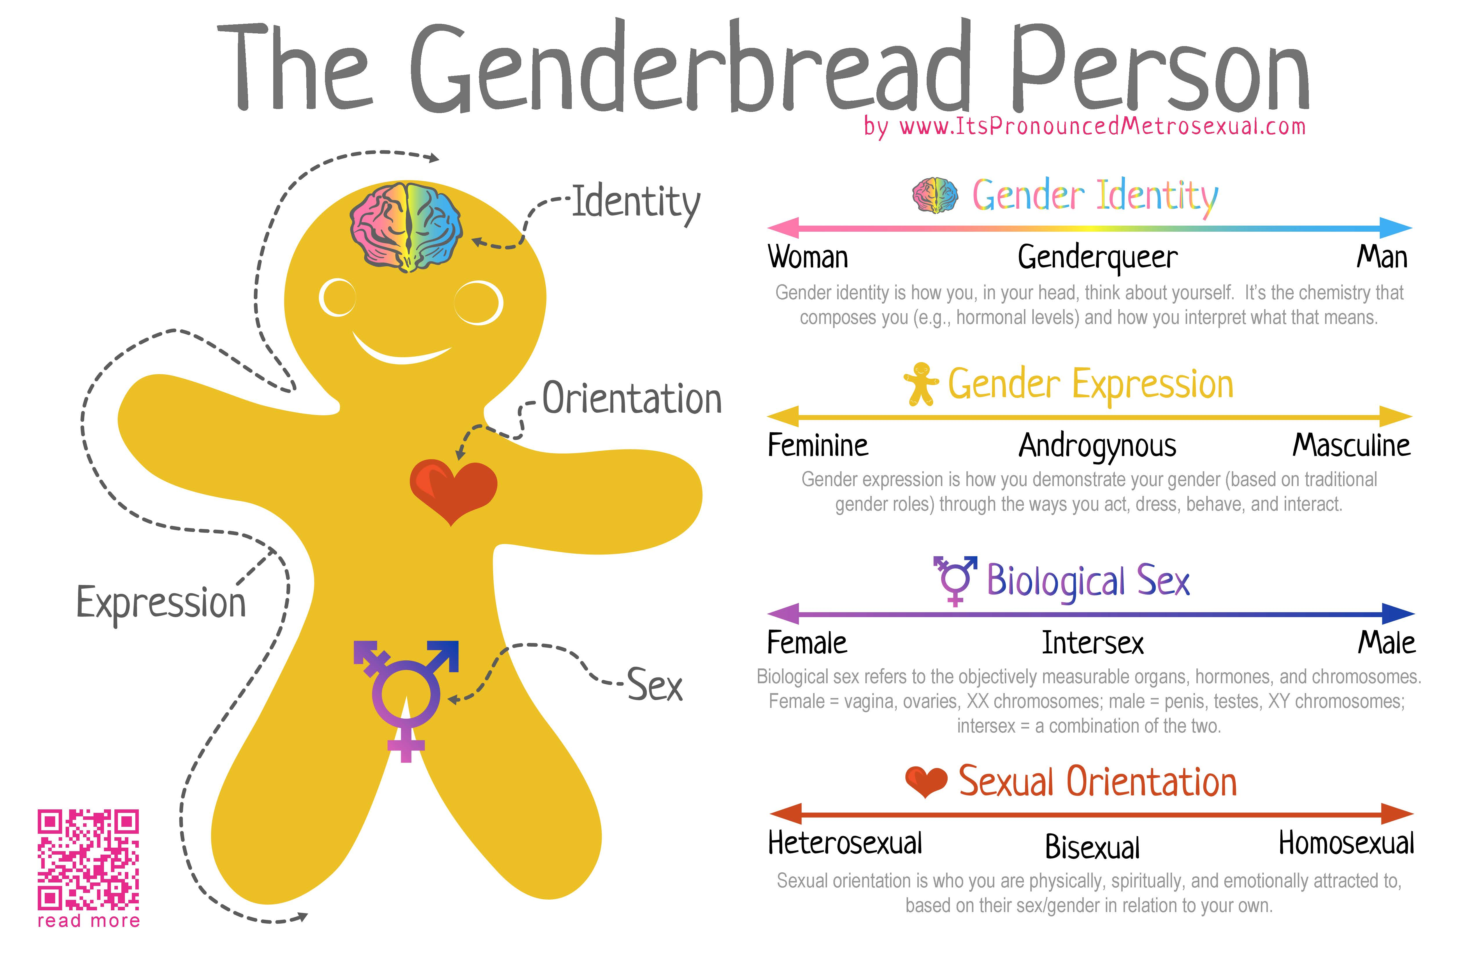
Fig 1. The Gender Bread Person (2013). Breaking through the binary: Gender explained using continuums. Retrieved from: URL to Source

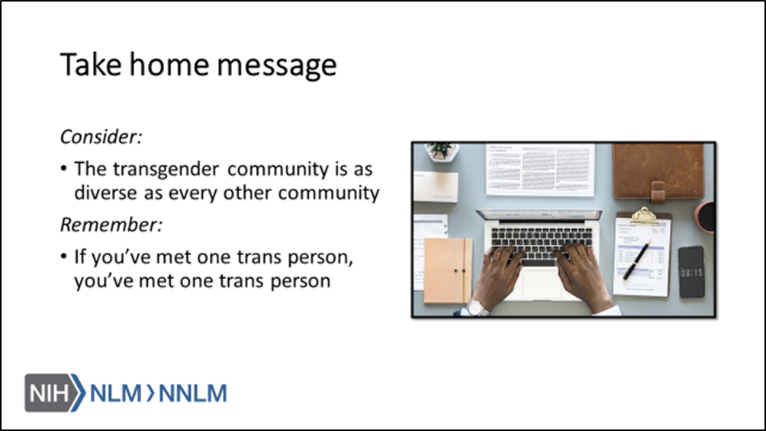

References:
- Human Rights Campaign. “LGBTQ Definition for Adults: Welcoming Schools.” Human Rights Campaign, URL to Source
- “Glossary of Terms – Transgender.” GLAAD Media Reference Guide – Transgender, GLAAD, URL to Source
- “Social Transitioning.” Beyond Gender, The Trevor Project, 2016, URL to Source
- The Gender Bread Person (2013). Breaking through the binary: Gender explained using continuums. Retrieved from: URL to Source
- Trans Student Educational Resources (2019). Infographics. Retrieved from: URL to Source
- Reiff, M. & Mays, J. (2013). The Gender Book. Houston: Marshall House Press

