Hello everyone,

Thank you for your willingness to participate in today’s Clinical Conversation, which was an introduction to health literacy. To learn more about this topic, I suggest looking over some of the resources linked on the Health Literacy topic page in the National Library of Medicine’s consumer health portal, MedlinePlus. The links here can help us consider why health literacy is important in our professional roles. When you have time, click the image below to look a few of these over.

[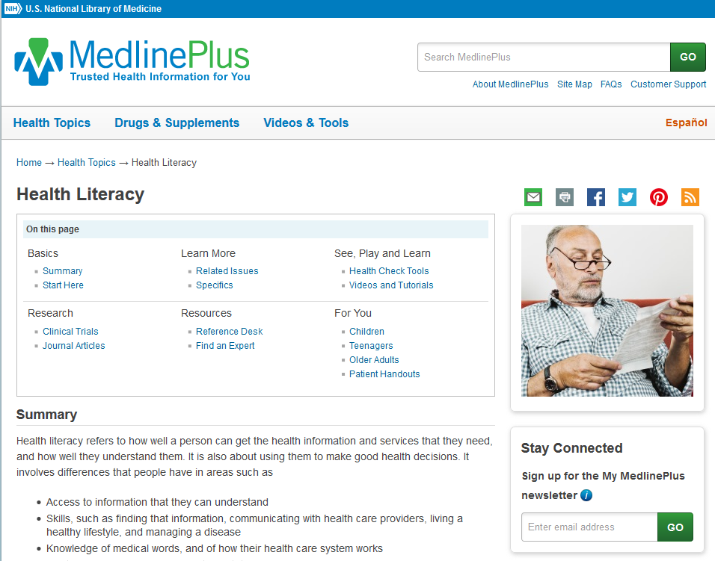](https://medlineplus.gov/healthliteracy.html)