Word 365 Accessibility (Make this a Heading 1)
Step 1: Locate and run the Word 365 Accessibility Checker (Make this Heading 2)
- Go to File, then select Info.
- Next, click on Check for Issues.
- Then click on Check Accessibility. This will run the checker.
A panel will open on the right side of the document. In addition to listing the errors, the checker will describe how to fix them. You can rerun the checker as needed.
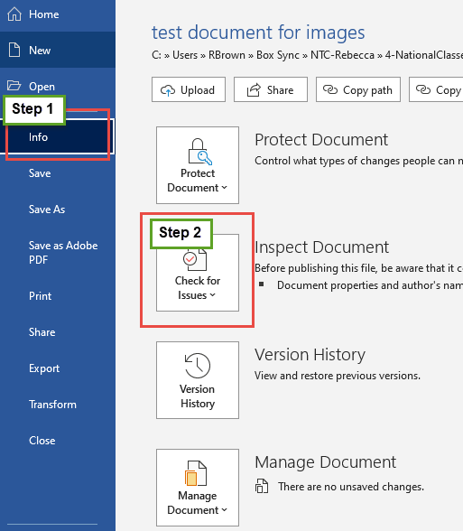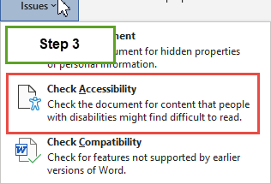
Image 1 & 2: Accessibility Checker location in Word 365
Step 2: Use Built-in Styles (Make this Heading 2)
How to Apply Headings: (Make this Heading 3)
- Using the Home tab on the Word ribbon, locate the Styles section (see image below)
- You can use the small arrow in the lower-right of the Styles box to pop-out the section.
- Highlight the document title, select Heading 1.
- Highlight the section titles (Step 1, Step 2, etc.), select Heading 2.
- When you apply a heading, the format of the text will change. Feel free to change the font, font size and color. The applied heading tag will remain intact.
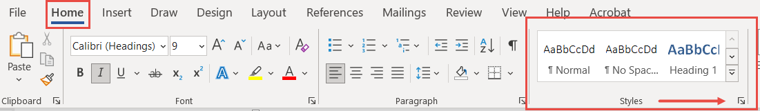
Image 3: Styles ribbon in Word 365

Step 3: Add Alternative Text to Images (Make this Heading 2)
- Right click on the image.
- Choose View Alt-Text from the context menu that displays.
- The ‘Alt-text’ panel will appear on the right side of the document.
- No need to say “this is an image of…” because the screen reader will announce it’s an image.
- If the image is purely decorative, check the box that says “Mark as decorative”. Consider removing purely decorative images from the document.
- Add a description in the box.
- You can automatically generate alt-text, however, make sure to read what was generated. In most cases, the auto-text is not accurate. For example, the auto-generated text for the image of the alt-text panel below was: Graphical user interface, text, application, chat or text message.
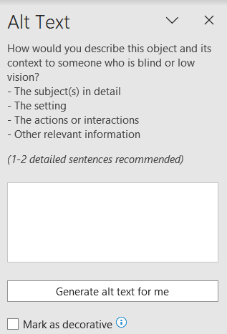
Image 4: alt-text panel in Word 365

Your turn: Use the image and text below to practice adding alt-text.
Book titled Accessibility for Everyone by Laura Kalbag. 2017.
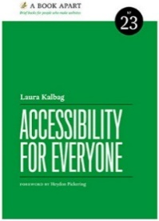
Step 4: Use Descriptive Hyperlinks (Make this heading 2)
Instead of inserting a URL into the body of the document, use descriptive hyperlinks. For someone using a screen reader, descriptive text is preferred because the text tells them where the link will take them and allows them to avoid having to listen to the screen reader read the full URL. This will make the document end-user friendly.
How to add a descriptive hyperlink: (Make this Heading 3)
- Ask yourself what do users need to know about this link?
- Write descriptive text. Do not say Click Here. This does not tell the end-user where the link will take them.
- Highlight the text you want to link.
- Then, right-click the text you highlighted.
- Click Link that appears in the context menu that appears.
- Add the URL into the Address section of the box.
- Click on ‘OK’ to save.
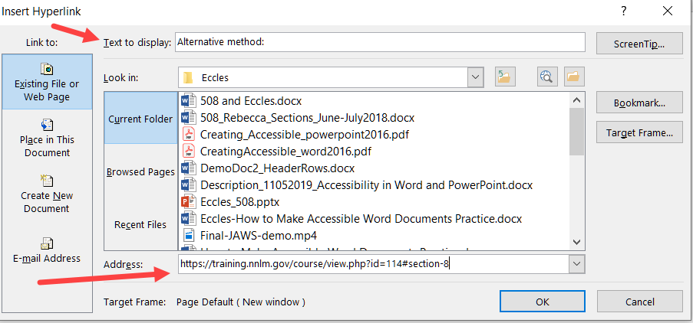
Image 5: Add URL to the Address section.

Your Turn: Convert the text and URL below into a descriptive hyperlink.
Register now for the summer session of 5 Steps to an Accessible Document.
https://www.nnlm.gov/training/class/5-steps-accessible-document

Step 5: Check color (Make this Heading 2)
- Color should not be used as the only means of conveying information.
- Text color should have sufficient contrast from the background so that it can be easily seen.
A few things to keep in mind: (Make this Heading 2)
- The accessibility checker cannot determine if your alt-text is correct.
- If you use auto-generated alt-text, confirm that it correctly describes the item.
- The checker cannot determine if your headings are in the right order.

You are now done with this document.

