Food Insecurity Defined
“Food insecurity refers to USDA’s measure of lack of access, at times, to enough food for an active, healthy life for all household members and limited or uncertain availability of nutritionally adequate foods. Food-insecure households are not necessarily food insecure _______________________. Food insecurity may reflect a household’s need to make _____________________ between important basic needs, such as housing or medical bills, and purchasing nutritionally adequate foods” ⁹
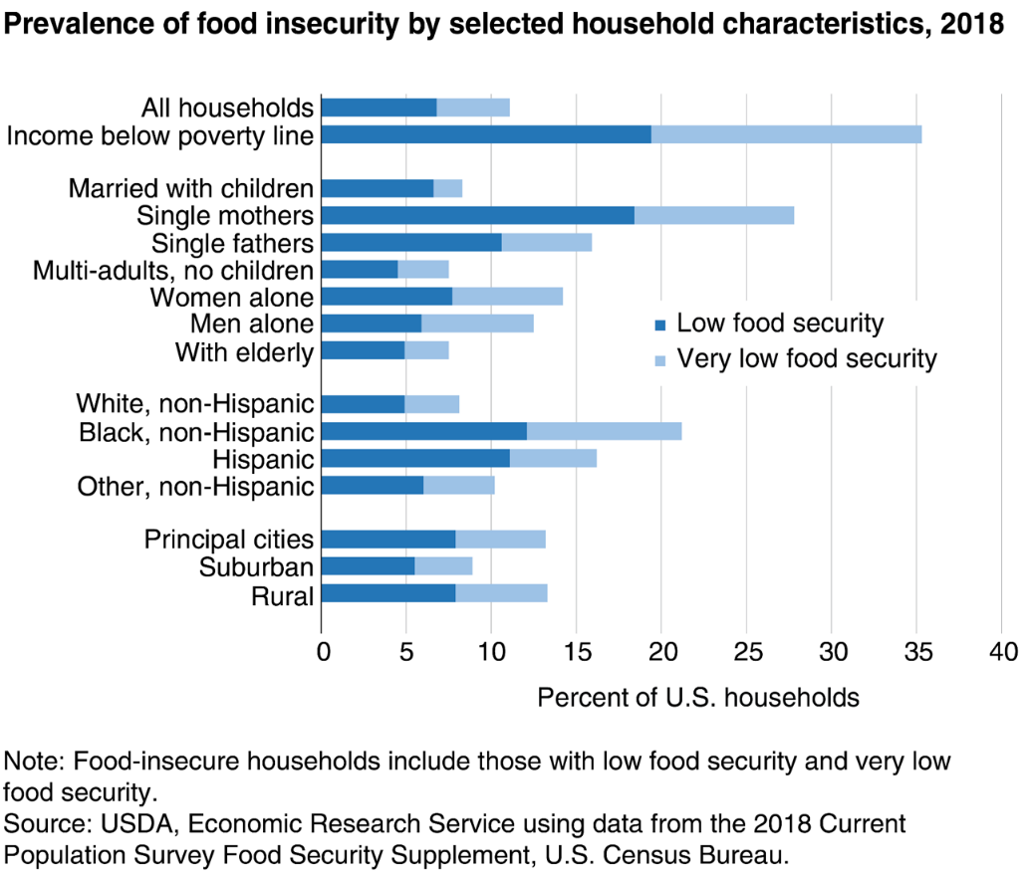

Fig. 1 United States Food and Drug Administration (2019). Food insecurity rates are highest for single mother households and households with incomes below poverty line. Retrieved from: URL to Source

Ask One More Question
- In the past 12 months, have you worried if food would run out before you had money to buy more?
- Do you know where to access/find vegetables and fruits (local produce programs)?
- Do you have a way to get to and from the produce program?

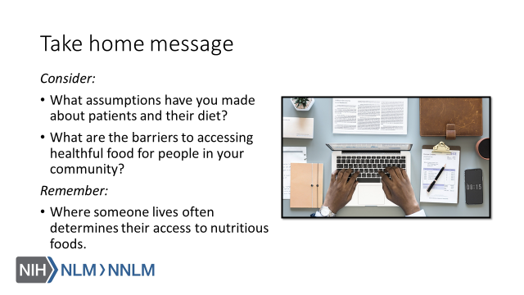

References:
- Lee A, Cardel M, Donahoo WT. Social and Environmental Factors Influencing Obesity. 2019 Oct 12. In: Feingold KR, Anawalt B, Boyce A, et al., editors. Endotext [Internet]. South Dartmouth (MA): MDText.com, Inc.; 2000-. Available from: URL to Source
- American Diabetes Association (n.d). Statistics About Diabetes. Available at: URL to Source
- U.S. National Library of Medicine. MedlinePlus. Heart Diseases. Available at: URL to Source
- Frostegård J. Immunity, atherosclerosis and cardiovascular disease. BMC Med. (2013) 11:117. 10.1186/1741-7015-11-117. Available at: URL to Source
- United States Department of Agriculture. Definitions of Food Insecurity. Available at: URL to Source
- Rabbitt, M., Coleman-Jensen, A. and Gregory, C. USDA ERS - Understanding the Prevalence, Severity, and Distribution of Food Insecurity in the United States. USDA.gov, 2019. Available at: URL to Source
- Dinour LM, Bergen D, Yeh MC. The food insecurity-obesity paradox: a review of the literature and the role food stamps may play. Journal of the American Dietetic Association. 2007;107(11):1952–61. doiI: URL to Source
- Dhurandhar EJ. The food-insecurity obesity paradox: A resource scarcity hypothesis. Physiol Behav. 2016;162:88–92. doi:10.1016/j.physbeh.2016.04.025
- Feeding South Dakota (2019). What is “Food Insecurity?”. Retrieved from: URL to Source
- United States Food and Drug Administration (2019). Food insecurity rates are highest for single mother households and households with incomes below poverty line. Retrieved from: URL to Source
- Hunger + Health (2019). What is Food Insecurity? Retrieved from: URL to Source
- National Institute of Diabetes and Digestive Kidney Diseases [NIDDK] (2016). Symptoms & Causes of Diabetes. Retrieved from: URL to Source

