Evidence-Based Practice (EBP)
Evidence-based practice is the conscientious, explicit, and judicious use of current best evidence in making decisions about the care of individual patients¹.
The three major components of EBP include:
- External clinical evidence
- Integration of individual clinical expertise
- Patient preferences¹
Why EBP?
Benefits of EBP for patients include:
- Increased patient satisfaction²
- Increased patient safety³
- Improved clinical outcomes⁴
- Decrease in variability/variation in delivery of care and patient outcomes³
Benefits of EBP for practitioners include:
- Greater job satisfaction and group cohesion⁵
- Meeting a mandated core competency (Institute of Medicine)⁶
- Opportunities for research and publication⁷
Benefits of EBP for organizations include:
- Greater cost efficiency⁵
- Lower rates of staff turnover⁵
The EBP process (5 As)⁸:
3. Appraise
4. Apply
5. Assess

1. Ask
2. Acquire

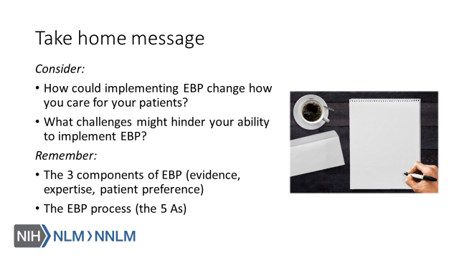
References
- Sackett, D.L. (1996). Evidence based medicine: What it is and what it isn’t. BMJ, 312(7023), 71-72. Retrieved from URL to Source.
- Skaggs, M.K.D., Daniels, J.F., Hodge, A.J., & DeCamp, V.L. (2018). Using the evidence-based practice service nursing bundle to increase patient satisfaction. Journal of Emergency Nursing, 44(1), 37-45. Retrieved from URL to Source.
- Peterson, E.D., Bynum, D.Z., & Roe, M.T. (2008). Association of evidence-based care processes and outcomes among patients with acute coronary syndromes: Performance matters. Journal of Cardiovascular Nursing, 23(1), 50-55. Retrieved from URL to Source.
- Popovich, M.A., Boyd, C., Dachenhaus, T., & Kusler, D. (2012). Improving stable patient flow through the emergency department by utilizing evidence-based practice: One hospital’s journey. Journal of Emergency Nursing, 38(5), 474-478. Retrieved from URL to Source.
- Levin, R.F., Fineout-Overholt, E., Melnyk, B.M., Barnes, M., & Vetter, M.J. (2011). Fostering evidence-based practice to improve nurse and cost outcomes in a community health setting: A pilot test of the advancing research and clinical practice through close collaboration model. Nursing Administration Quarterly, 35(1), 21-33. Retrieved from URL to Source.
- Greiner, A.C. & Knebel, E. (2003). Health professions education: A bridge to quality. Washington, DC: National Academies Press. Retrieved from URL to Source.
- Coleman, D.E., Kamai, S., & Finn Davis, K. (2018). Impact of a collaborative evidence-based practice nursing education program on clinical operations. Journal of Hospital Librarianship, 18(4), 323-330. Retrieved from URL to Source.
- Straus, S.E., Glasziou, P., Richardson, W.S., & Haynes, R.B. (2011). Evidence-based medicine: How to practice and teach it. Philadelphia: Churchill Livingstone.

