What is Action?

A person had made changes to their behaviors or lifestyle within the past six months²

Core principles + OARS for someone in Action
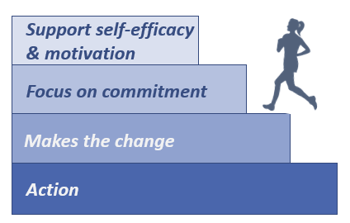
- Help them stay on track³
- Support ______________¹
  - Affirmations⁴
- Consider their support system³

Figure 1. Adapted from Tuccero, Railey, Briggs & Hull (2016). Behavioral Health in Prevention and Chronic Illness Management, Primary Care: Clinics in Office Practice, 43, 191-102. doi: 10.1016/j.pop.2016.01.006
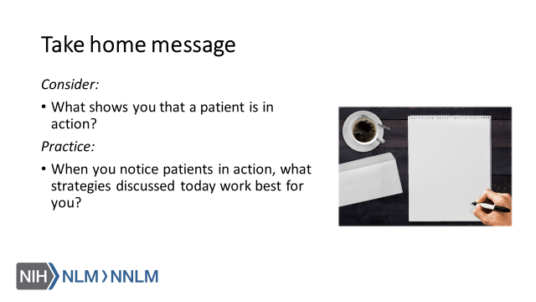

References:

- Tuccero, Railey, Briggs & Hull (2016). Behavioral Health in Prevention and Chronic Illness Management, Primary Care: Clinics in Office Practice, 43, 191-102. doi: 10.1016/j.pop.2016.01.006
- Glanz, K., Rimer, B. & Viswanath, K. (Eds.). (2015). Health Behavior: theory, research and practice. San Francisco: Jossey-Bass.
- Constance, A. & Sauter, C. (2011). Inspiring and Supporting Behavior Change. United States: American Dietetic Association.
- Gold, M., Kelly, T., Douihy, A. (2015). Motivational Interviewing: A Guide for Medical Trainees. New York: Oxford University Press.
- McGinnis P., Davis M., Howk S., DeSordi M. & Thomas M. (2014). Integrating Primary Care Practices and Community-based Resources to Manage Obesity: A Bridge-building Toolkit for Rural Primary Care Practice Transformation. Rockville, MD: Agency for Healthcare Research and Quality: AHRQ Publication No. 14-0043-EF. Retrieved from URL to source
- Stewart, E., Taylor-Post, N., Nichols L., Staton E., & Schleuning A. (2014). Community Connections: Linking Primary Care Patients to Local Resources for Better Management of Obesity. Rockville, MD: Agency for Healthcare Research and Quality; AHRQ Publication No. 14-0030-EF. Retrieved from URL to Source
- Center for Substance Abuse Treatment (1999). Enhancing Motivation for Change in Substance Abuse Treatment. Treatment Improvement Protocol (TIP) Series, No. 35. HHS Publication No. (SMA) 12-4212. Rockville, MD: Substance Abuse and Mental Health Services Administration. Retrieved from URL to Source

