TTM-Cyclical process
Theory that assumes change progresses over time, with someone going through six stages of change, with different needs based on where they are in the change process^{2,5}.
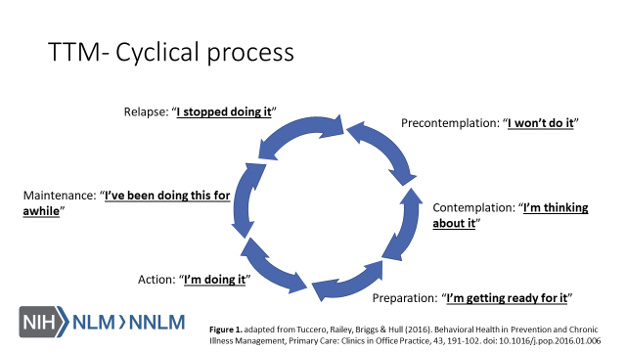

TTM-Link to Motivational Interviewing
TTM provides a framework for understanding behavior change, but motivational interviewing is how one person can help another person move through the change process^{4,6}.

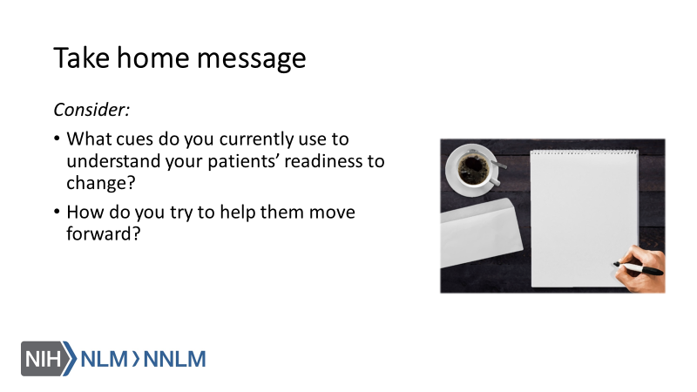
References:

- Tuccero, Railey, Briggs & Hull (2016). Behavioral Health in Prevention and Chronic Illness Management, Primary Care: Clinics in Office Practice, 43, 191-102. doi: 10.1016/j.pop.2016.01.006
- Glanz, K., Rimer, B. & Viswanath, K. (Eds.). (2015). Health Behavior: theory, research and practice. San Francisco: Jossey-Bass.
- Constance, A. & Sauter, C. (2011). Inspiring and Supporting Behavior Change. United States: American Dietetic Association.
- Gold, M., Kelly, T., Douihy, A. (2015). Motivational Interviewing : A Guide for Medical Trainees. New York: Oxford University Press.
- Prochaska, J. (1997). The Transtheoretical Model of Health Behavior Change. American Journal of Public Health, 12(1), 38-48.
- Britt, E., Hudson, S. & Blampied, N. (2003). Motivational Interviewing in Health Settings: A Review, 53, 147-155.

