Hello everyone,
Thank you for attending our sixth Clinical Conversation where we discussed motivational interviewing the preparation stage. One of the suggestions was to use affirmations to support self-efficacy¹. Here’s a quick idea of what this might look like.
[NOTE TO FACILITATOR: if you used this image as part of the e-mail follow up in module 2, we suggest either not using it in this module, or changing the phrasing above to state that is it a repeat, of the affirmation demonstration that was sent out during module 2 as a reminder for this stage.]
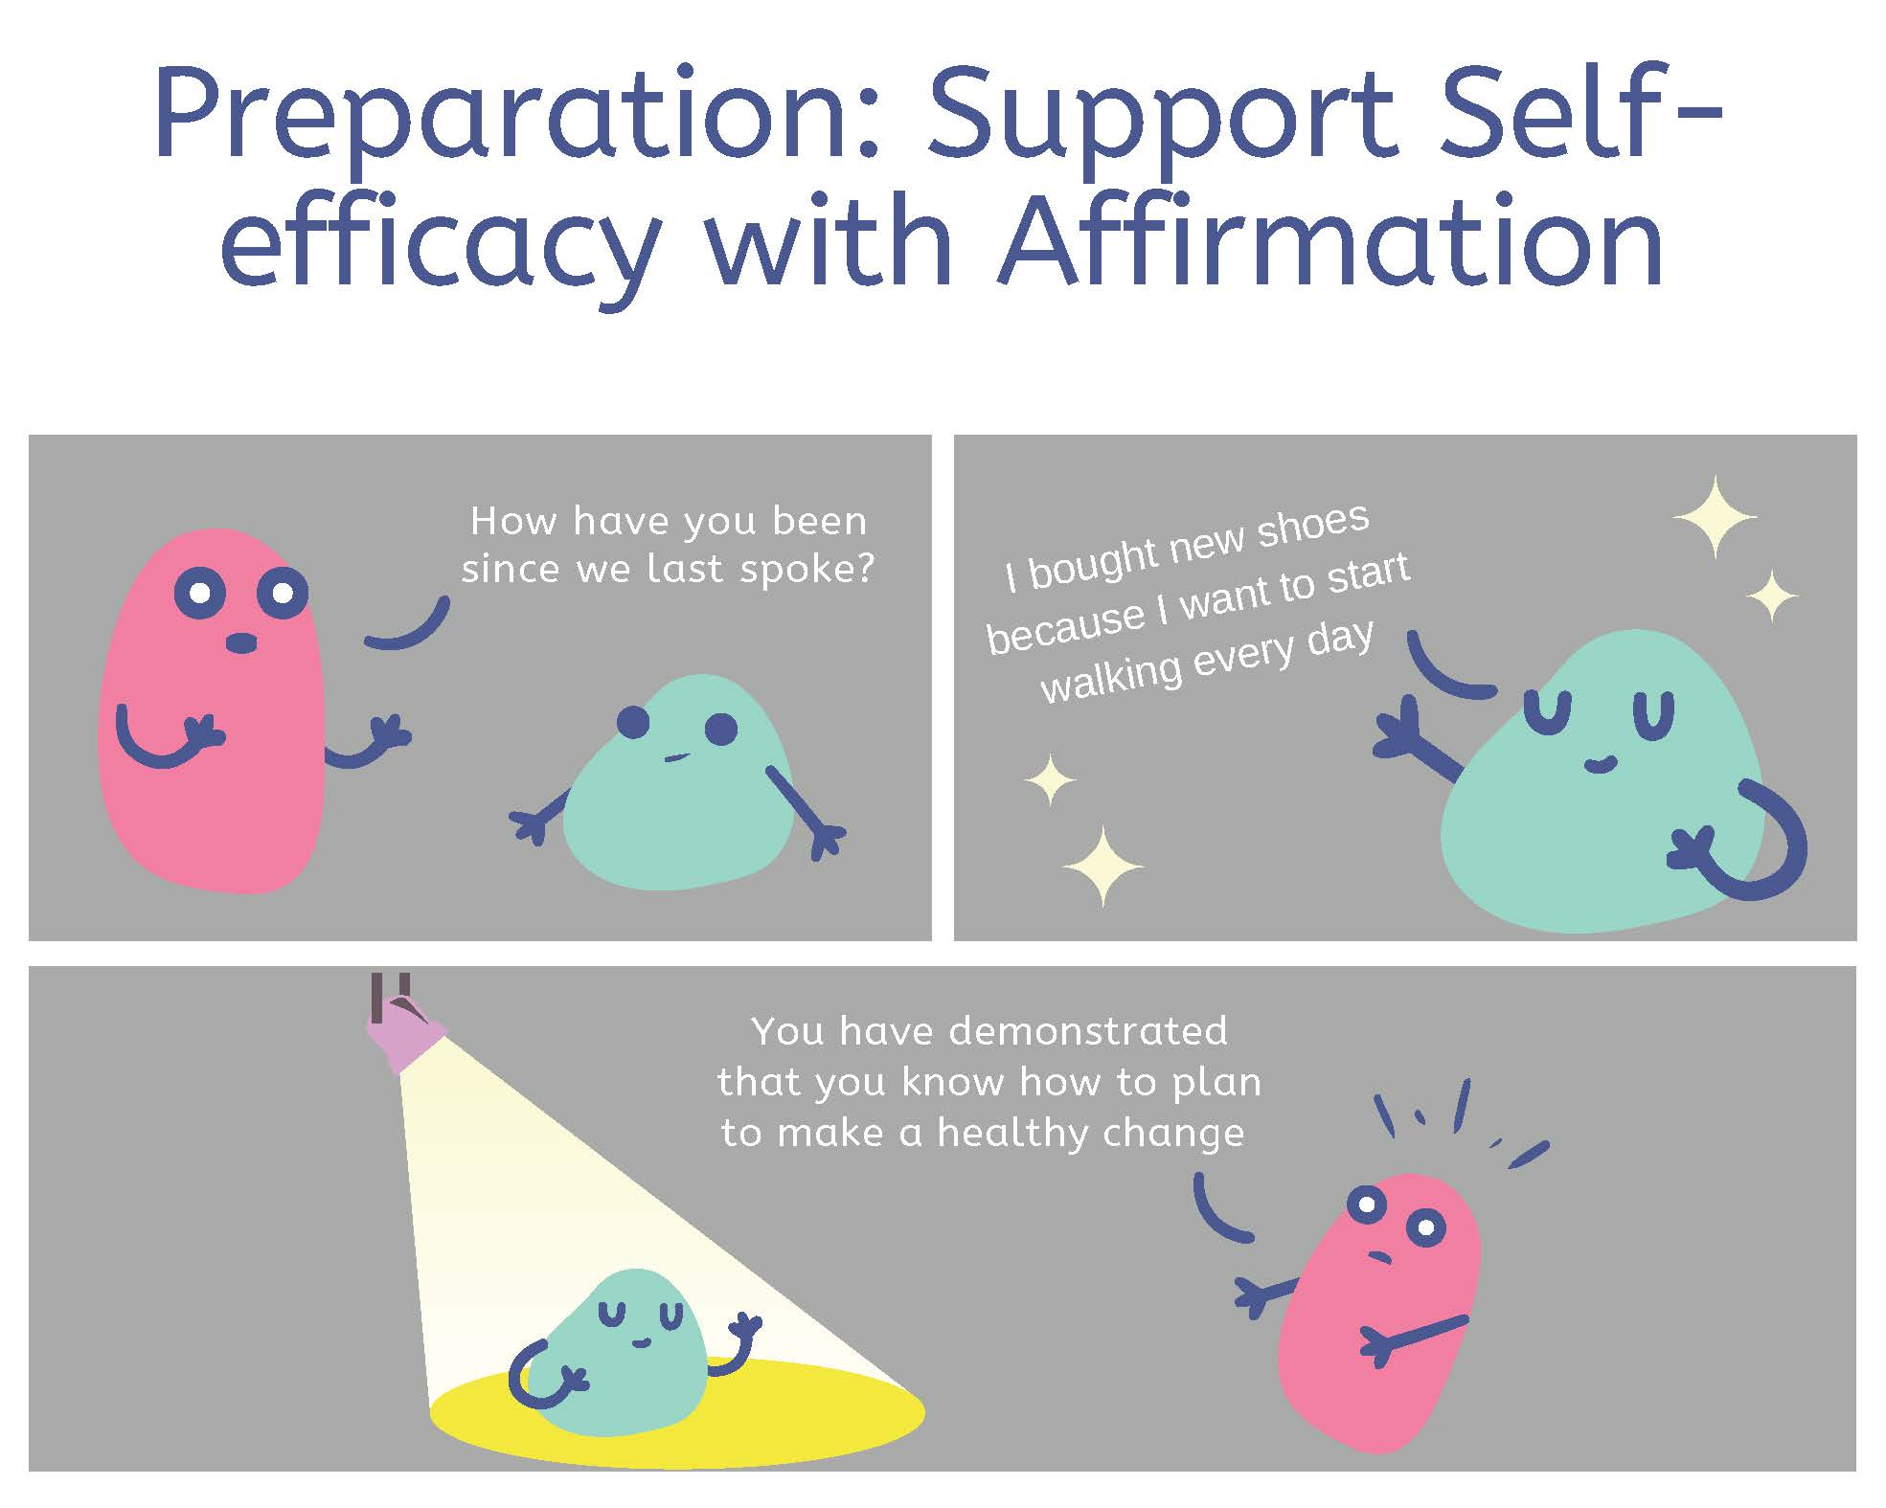

References:
- Tuccero, Railey, Briggs & Hull (2016). Behavioral Health in Prevention and Chronic Illness Management, Primary Care: Clinics in Office Practice, 43, 191-102. doi: 10.1016/j.pop.2016.01.006

