Hi Everyone,
Thank you for participating in our second discussion about motivational interviewing [this week, last Wednesday, etc.]. Here is an image that highlights questioning skills used in motivational interviewing. A quick way to remember these is using the acronym OARS.
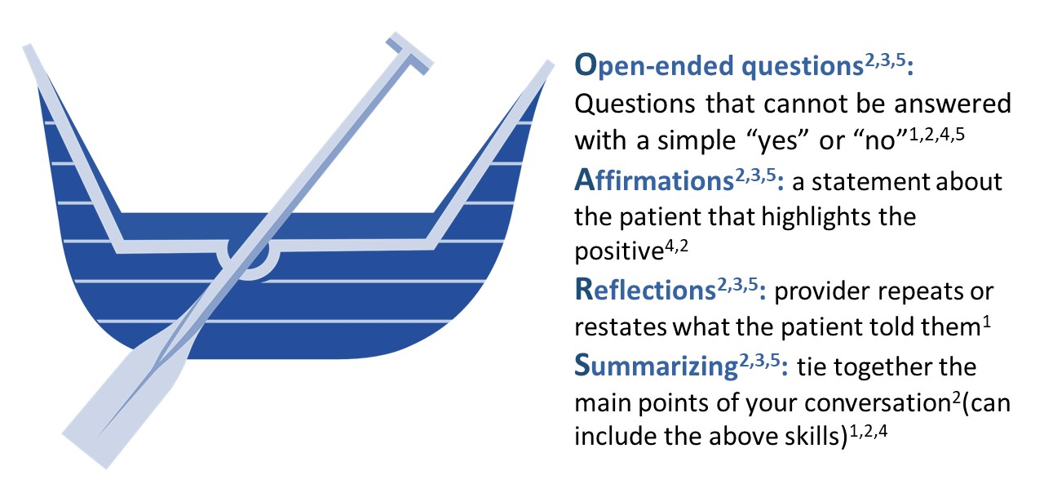

See you next time,

References:
- Constance, A. & Sauter, C. (2011). Inspiring and Supporting Behavior Change. United States: American Dietetic Association.
- Gold, M., Kelly, T., Douihy, A. (2015). Motivational Interviewing: A Guide for Medical Trainees. New York: Oxford University Press.
- Kelley, C., Sbrocco, G. & Sbrocco, T. (2016). Behavioral Modification for the Management of Obesity. Primary Care, 43(1), 159-175. doi: 10.1016/j.pop.2015.10.004
- McGinnis P., Davis M., Howk S., DeSordi M. & Thomas M. (2014). Integrating Primary Care Practices and Community-based Resources to Manage Obesity: A Bridge-building Toolkit for Rural Primary Care Practice Transformation.
- Stewart, E., Taylor-Post, N., Nichols L., Staton E., & Schleuning A. (2014). Community Connections: Linking Primary Care Patients to Local Resources for Better Management of Obesity. Rockville, MD: Agency for Healthcare Research and Quality; AHRQ Publication No. 14-0030-EF. Retrieved from URL to Source

