Hello everyone,
Thank you for attending our Clinical Conversation where we discussed tips for getting started with motivational interviewing. During this conversation, we discussed the OARS method. The “A” in OARS stands for affirmations, which is when an MI provider highlights something positive about the patient^{1,2}. We talked about how these are different from praise³ or cheerleading. Here is a quick example of the difference between praise and affirmations. Affirmations start with “you” instead of “I”¹.

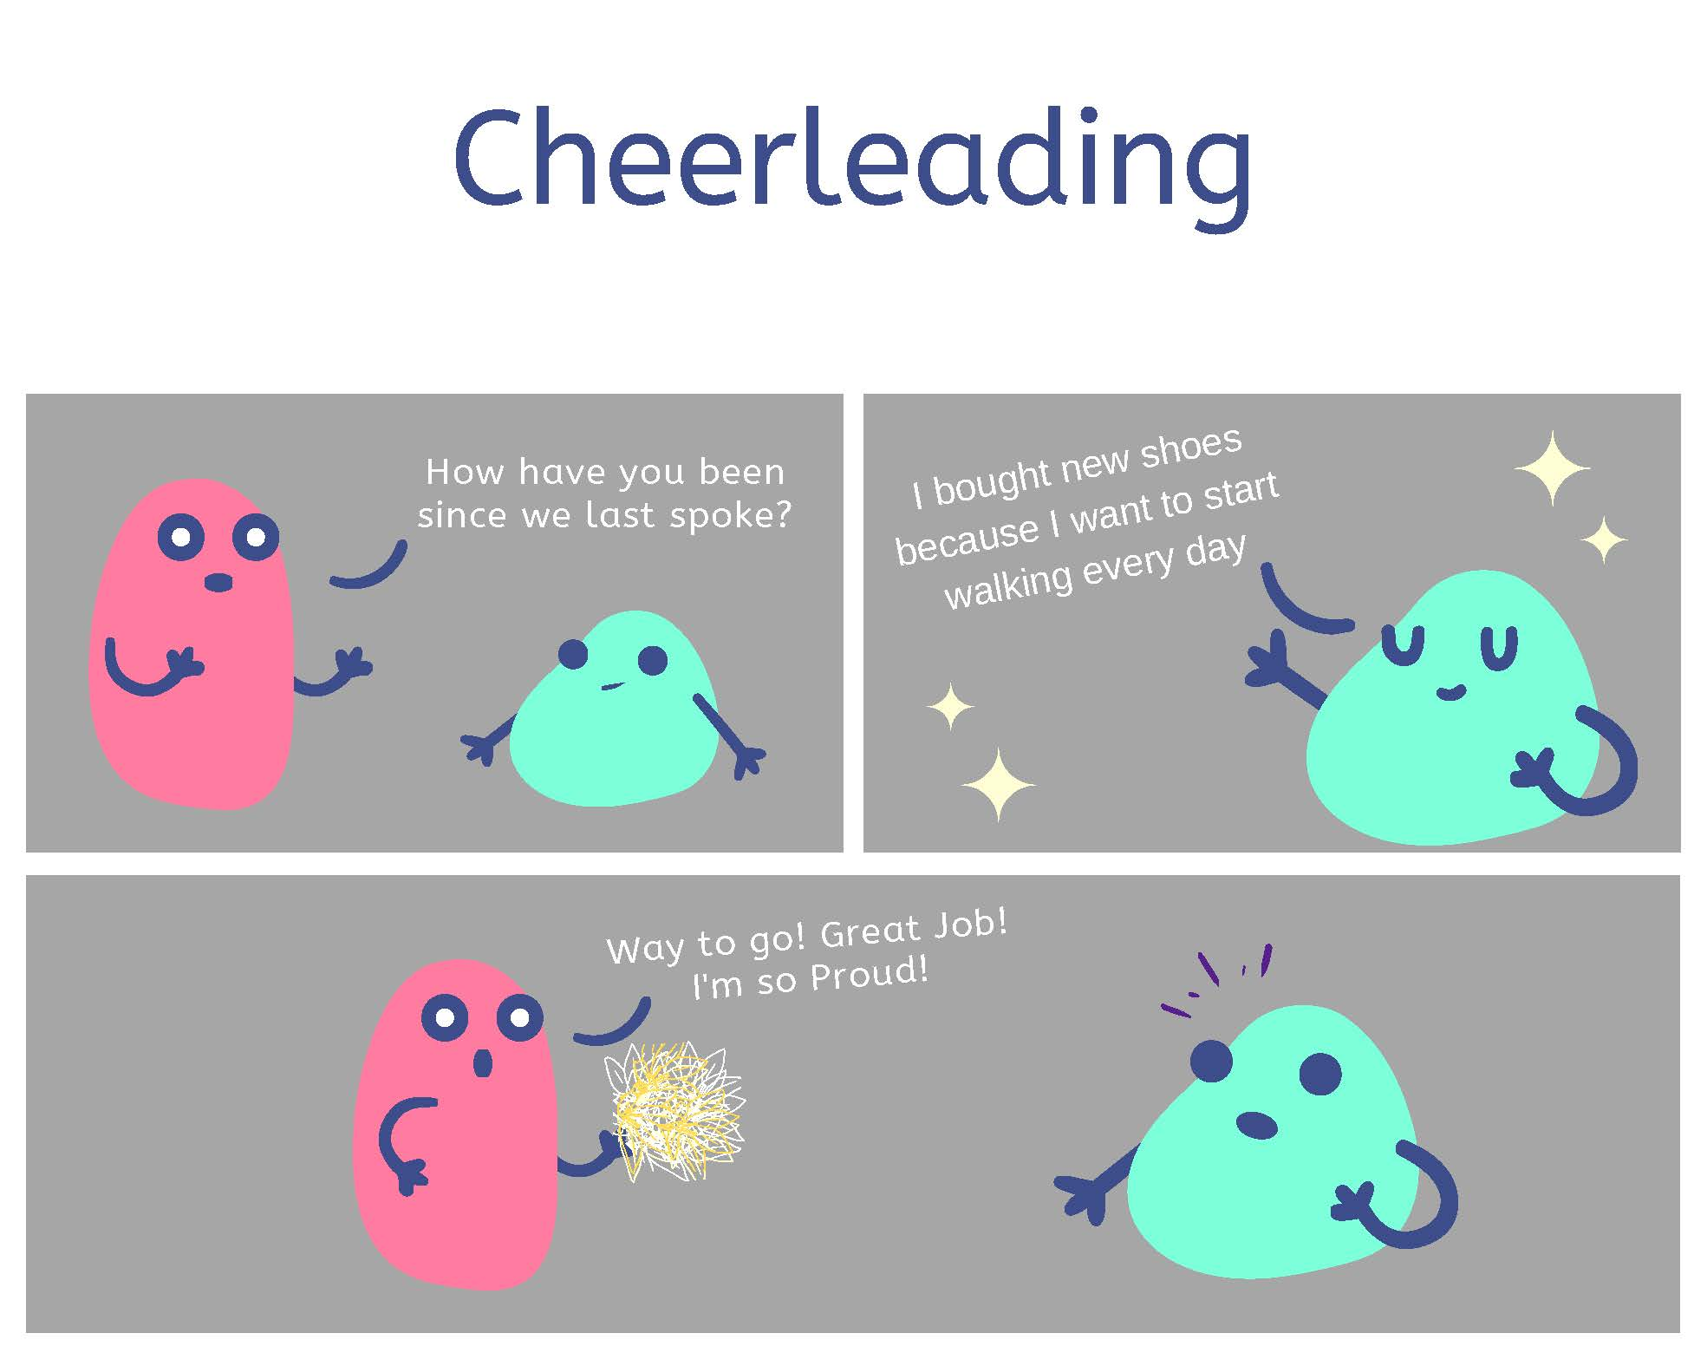
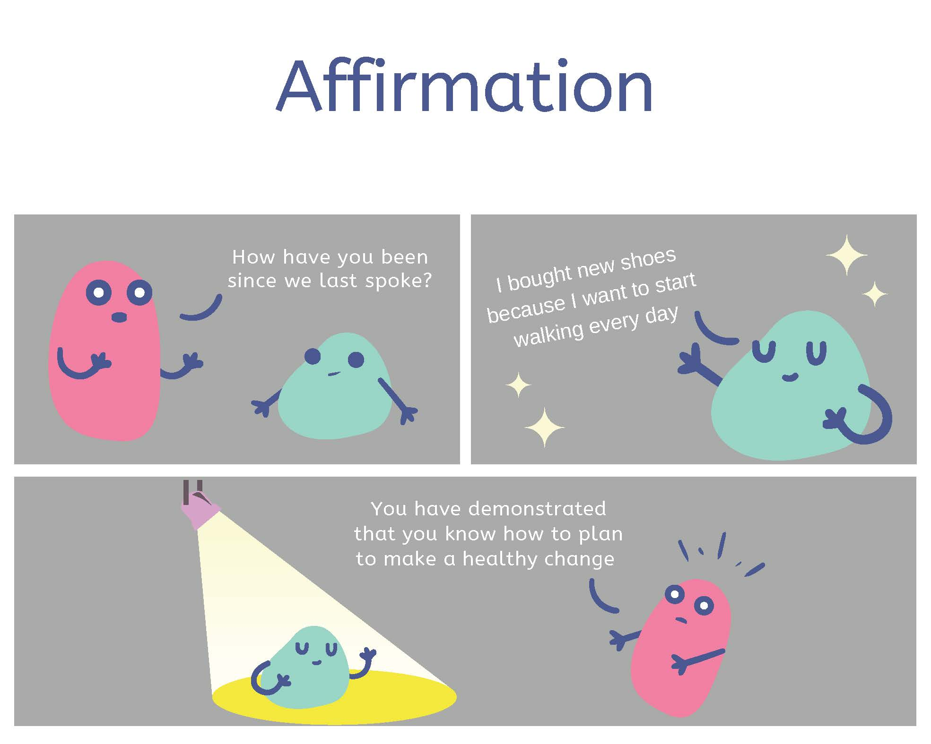

References:
- Gold, M., Kelly, T., Douihy, A. (2015). Motivational Interviewing: A Guide for Medical Trainees. New York: Oxford University Press.
- McGinnis P., Davis M., Howk S., DeSordi M. & Thomas M. (2014). Integrating Primary Care Practices and Community-based Resources to Manage Obesity: A Bridge-building Toolkit for Rural Primary Care Practice Transformation.
- Constance, A. & Sauter, C. (2011). Inspiring and Supporting Behavior Change. United States: American Dietetic Association.

