Where should I look first?
The two most popular first ways for health practitioners to try to answer research questions are: do an _______________ _________________; consult a ________________¹. However, there are more reliable places to find information.
Free online research resources from the National Library of Medicine (NLM) [see handout for more details]:
- PubMed
- ClinicalTrials.gov
- Drug Information Portal
- DailyMed
- Open-i
Other subscription-based databases:
- CINAHL (nursing)
- Embase (biomedical & pharmacy)
- PsycINFO (psychology)
- Trip (EBP-oriented database)

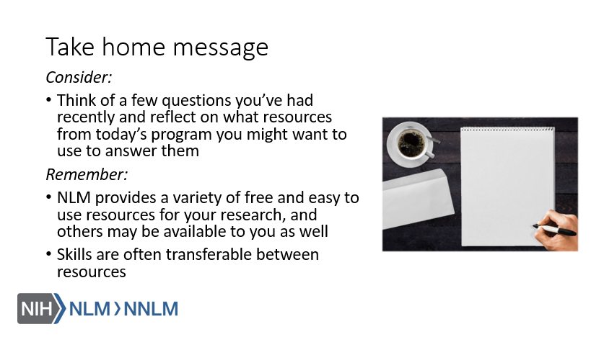
References:
- Alving, B.E., Christensen, J.B., Thrysøe, L. (2018). Hospital nurses’ information retrieval behaviors in relation to evidence based nursing: A literature review. Health Information and Libraries Journal, 35, 3-23. Retrieved from URL to Source.

