Hello everyone,
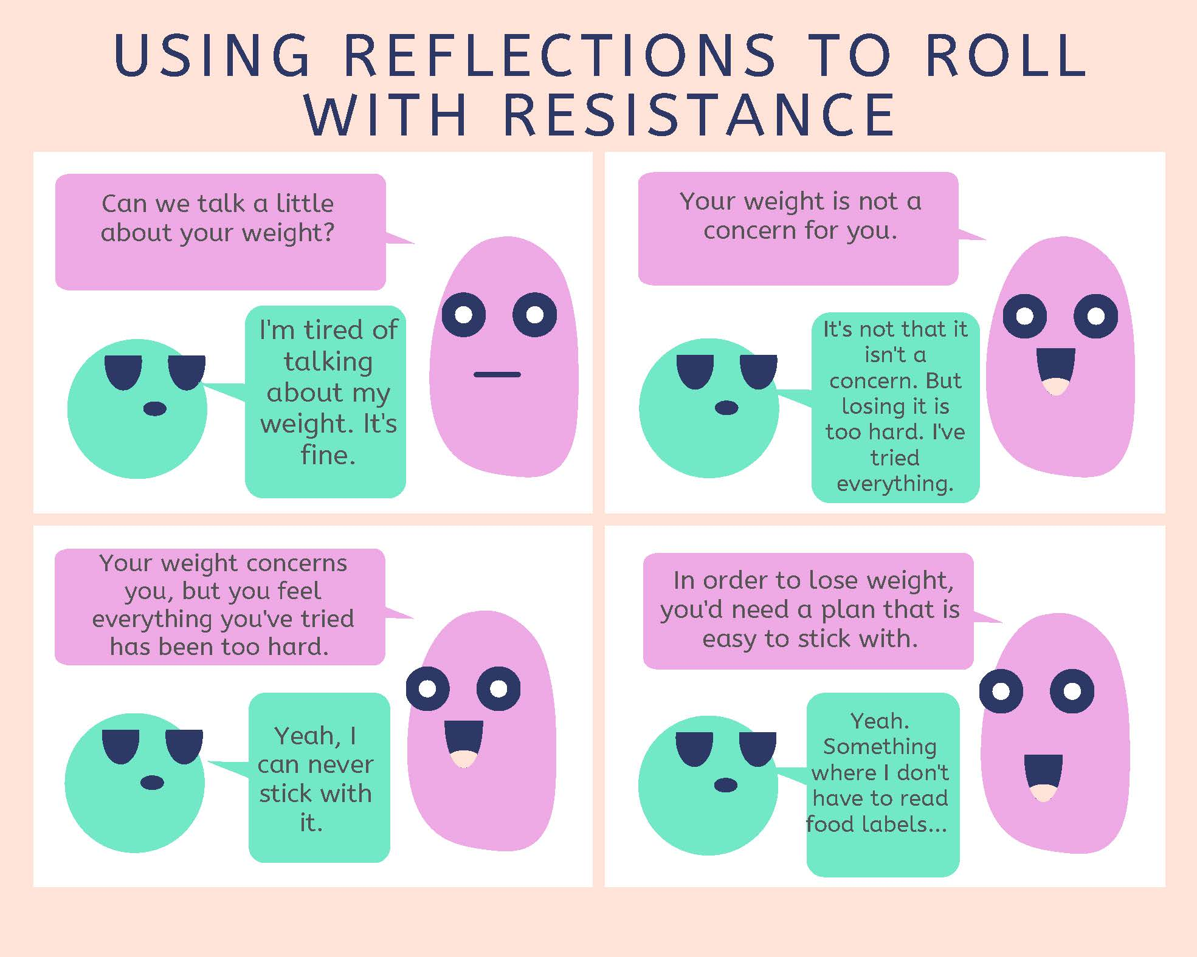
Thank you for attending our Clinical Conversation where we discussed MI and precontemplation. During this conversation, we discussed different MI strategies for working with someone in precontemplation. One of these was rolling with resistance¹. One OARS skill associated with the core MI principle of rolling with resistance is reflection^{2,3}. Here is a quick example of what this could look like. This example aligns with one of the reasons for being in contemplation that we discussed, where someone may be in this stage because they lack the self-confidence to change⁴.

See you next time,
References:
- Tuccero, Railey, Briggs & Hull (2016). Behavioral Health in Prevention and Chronic Illness Management, Primary Care: Clinics in Office Practice, 43, 191-102. doi: 10.1016/j.pop.2016.01.006
- Rollnick, S., Miller, W., Butler, C. (2008). Motivational Interviewing in Healthcare. Guilford press: New York
- Dartmouth Psychiatric Research Center [Dartmouth]. 2009, August 6. Practice Demonstration Video - Motivational Counseling [video file]. Retrieved from URL to Source
- Constance, A. & Sauter, C. (2011). Inspiring and Supporting Behavior Change. United States: American Dietetic Association.

