In the Gender Non-Conforming and Non-Binary module today, we discussed the use of they/them/theirs pronouns as an acceptable use of singular pronouns. Let’s practice using gender-inclusive language.

Fill out the following conversation using they/them/theirs pronouns:

I had a great time with them this weekend. We went out to eat at this great restaurant and then we went back to their house. They have a great selection of board games. I lost almost every game! Who knew they were so good at monopoly!

Some people choose not to use any pronouns and prefer using their name instead. Fill out the following conversation using only their name, Ryan.

Ryan has a great car. I saw it last night. Ryan has been fixing it up. After I saw Ryan’s car we drove Ryan’s car out to an antique car show. Ryan’s car was a big hit!

Finally, use the lines below to discuss what you did last night or what you plan to do this weekend and with who but don’t use any gender revealing language.

My friend is coming to visit this weekend. They have never been to New York before so we’re going to show them the sites. We might even try to go to Radio City Music Hall. When we come back, we’ll probably relax with some hot tea in front of the TV. I’m really looking forward to spending time with them.

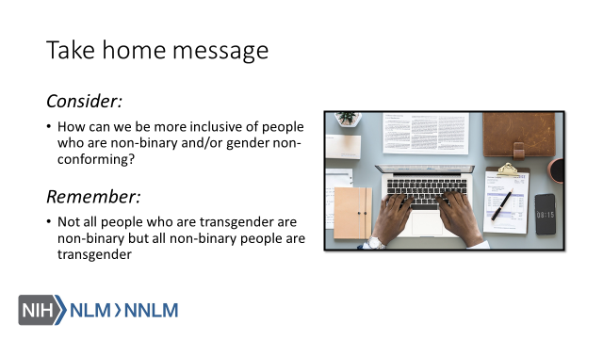

References:

- Human Rights Campaign. “LGBTQ Definition for Adults: Welcoming Schools.” Human Rights Campaign, URL to Source
- Brawbaw, Kasandra. “Allosexual, Demisexual, Bicurious - & Other Sexualities You Need to Know.” Refinery 29, 18 June 2019, URL to Source
- Brown, Eliza and Paula England. “Sexual orientation versus Behavior – Different for Men and Women?” Contexts.org, 29 February 2016, URL to Source
- California Coalition Against Sexual Assault (2017, June 28). Applying the Universe Model of Gender in Prevention [video file]. Retrieved from: URL to Source
- Trans Student Educational Resources (2019). Infographics. Retrieved from: URL to Source

