Core Principles
The core principles of Motivational Interviewing are⁴:
  - ___________________
  - ___________________
  - ___________________
  - ___________________
MI Related Skills- OARS
The core principles are goals of a motivational interviewing encounter, but require questioning skills. OARS stands for a set of skills that can help a provider reach these goals. OARS stands for:
- ______________________________: Questions that cannot be answered with a simple “yes” or “no”^{2,3,6,7}
- ______________________________: a statement about the patient that highlights the positive^{6,3}
- ______________________________: provider repeats or restates what the patient told them²
- ______________________________: tie together the main points of your conversation³ (can include the above skills)^{1,3,4}

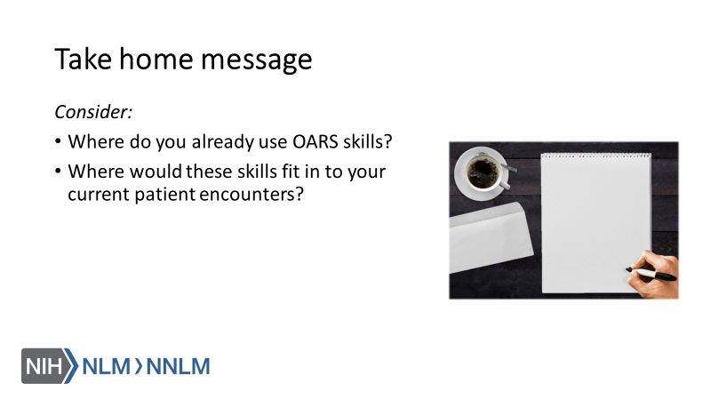

References:

- Tuccero, Railey, Briggs & Hull (2016). Behavioral Health in Prevention and Chronic Illness Management, Primary Care: Clinics in Office Practice, 43, 191-102. doi: 10.1016/j.pop.2016.01.006
- Constance, A. & Sauter, C. (2011). Inspiring and Supporting Behavior Change. United States: American Dietetic Association.
- Gold, M., Kelly, T., Douihy, A. (2015). Motivational Interviewing: A Guide for Medical Trainees. New York: Oxford University Press.
- Kelley, C., Sbrocco, G. & Sbrocco, T. (2016). Behavioral Modification for the Management of Obesity. Primary Care, 43(1), 159-175. doi: 10.1016/j.pop.2015.10.004
- Center for Substance Abuse Treatment (1999). Enhancing Motivation for Change in Substance Abuse Treatment. Treatment Improvement Protocol (TIP) Series, No. 35. HHS Publication No. (SMA) 12-4212. Rockville, MD: Substance Abuse and Mental Health Services Administration. Retrieved from URL to Source
- McGinnis P., Davis M., Howk S., DeSordi M. & Thomas M. (2014). Integrating Primary Care Practices and Community-based Resources to Manage Obesity: A Bridge-building Toolkit for Rural Primary Care Practice Transformation.
- Stewart, E., Taylor-Post, N., Nichols L., Staton E., & Schleuning A. (2014). Community Connections: Linking Primary Care Patients to Local Resources for Better Management of Obesity. Rockville, MD: Agency for Healthcare Research and Quality; AHRQ Publication No. 14-0030-EF. Retrieved from URL to Source

