Hi everyone,
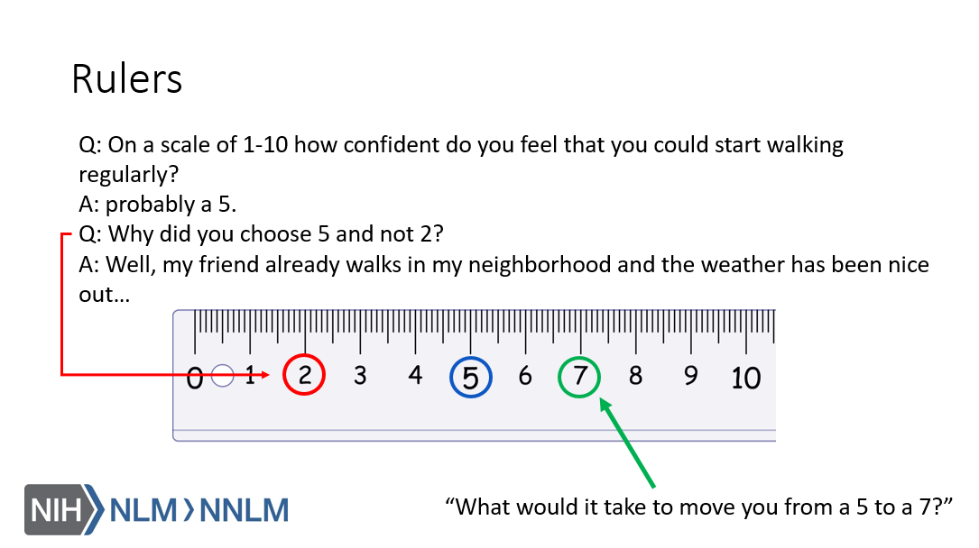
Thank you for attending our fifth Clinical Conversation about MI and the contemplation stage. One thing we discussed was the use of importance and confidence rulers. These can increase someone’s confidence and motivation to change^{1,2,3}, which is important when someone is in contemplation⁴.

References:
- Gold, M., Kelly, T. & Douihy, A. (2015). Motivational Interviewing: A Guide for Medical Trainees. New York: Oxford University Press.
- Stewart, E., Taylor-Post, N., Nichols L., Staton E., & Schleuning A. (2014). Community Connections: Linking Primary Care Patients to Local Resources for Better Management of Obesity. Rockville, MD: Agency for Healthcare Research and Quality; AHRQ Publication No. 14-0030-EF. Retrieved from URL to Source
- Center for Substance Abuse Treatment (1999). Enhancing Motivation for Change in Substance Abuse Treatment. Treatment Improvement Protocol (TIP) Series, No. 35. HHS Publication No. (SMA) 12-4212. Rockville, MD: Substance Abuse and Mental Health Services Administration. Retrieved from URL to Source
- Tuccero, Railey, Briggs & Hull (2016). Behavioral Health in Prevention and Chronic Illness Management, Primary Care: Clinics in Office Practice, 43, 191-102. doi: 10.1016/j.pop.2016.01.006

