Hi everyone,
Thanks for taking the time to learn about developing a research question today in the second module of our EBP lessons. Before our next session, take some time to think about some ways in which you think your research question could begin to guide you as you start to search for information to answer it. We’ll learn more about this in our next module.
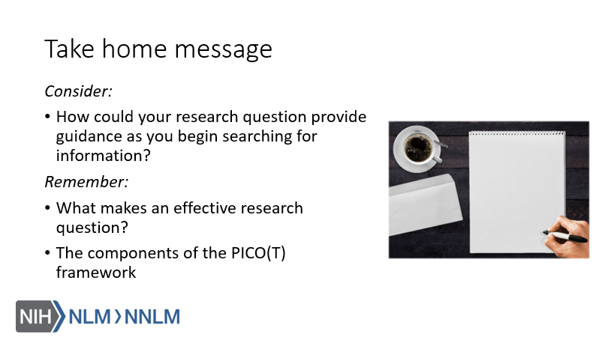
Also, if you have a few moments, try to develop a PICO(T) question for something that comes up during your time at work before our next session.

