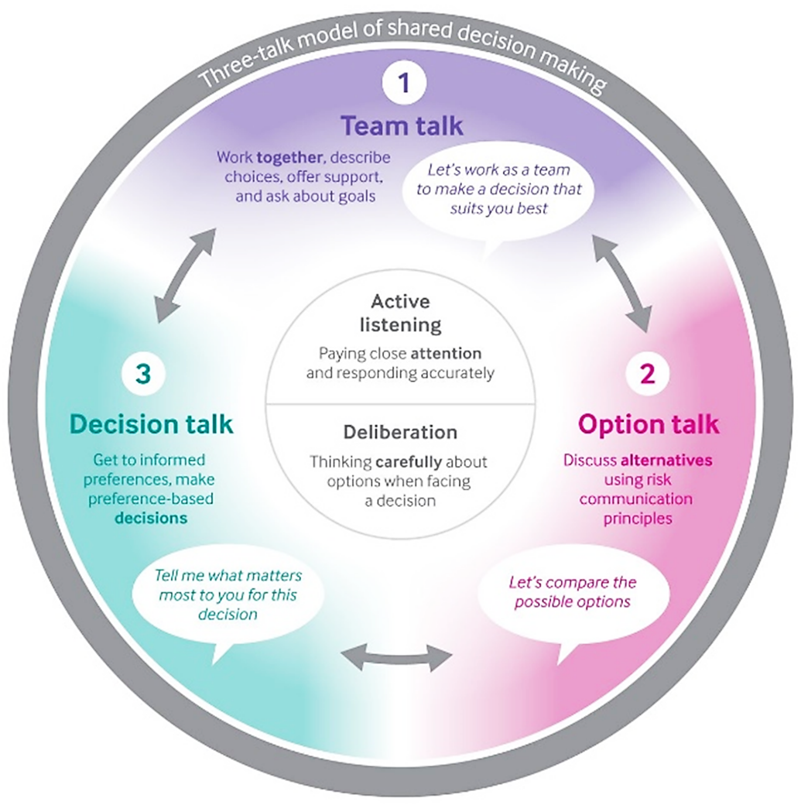
Shared Decision Making (SDM)
“An approach where clinicians and patients share the best available evidence when faced with the task of making decisions, and when patients are supported to consider options, to achieve informed preferences.”¹

Fig. 1 Elwyn Glyn, Durand Marie Anne, Song Julia, Aarts Johanna, Barr Paul J, Berger Zackary et al. A three-talk model for shared decision making: multistage consultation process BMJ 2017; 359:j4891

Ms. Orange (47) arrived at clinic today for uncontrolled diabetes and high blood pressure care. During intake she hesitantly mentioned she currently does not have a place to stay at night and is looking for a 2-Bedroom apartment, adding that she had an appointment last Wednesday at 9AM for housing with the city housing authority but missed the appointment due to lack of transportation. She has no income and is in need of winter clothing. She is currently unemployed due to health issues but would like to return to work. Her 20 year old son, diagnosed with autism, is enrolled in a Job Corp program but currently resides in a MH/MR residential facility outside of the city after completing an stabilization and acute care program. She would like to be able to visit him more frequently, but it is an hour walk from the nearest bus stop.

Question | Answer
What are the SDOH factors facing Ms. Orange? | housing, transportation, employment, SES
What do you suppose Ms. Orange’s priorities are? | 1. Finding a job; 2. Housing; 3. Making sure son continues to receive adequate care/support; 4. Winter clothes; 5. Medical care
Which of the three-talk strategies could you use to learn more? | Team Talk
How could you apply the three-talk model to better understand her preferences and help thinking carefully about these priorities? | This is an opinion

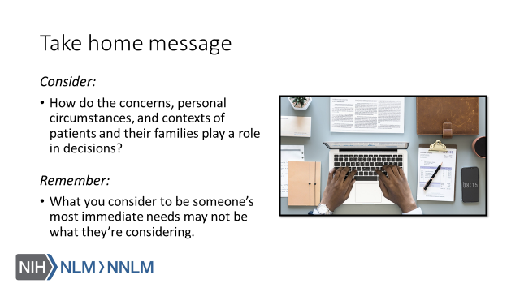

References:

- Elywn,G., Frosch, D., Thomson, R., Joseph-Williams, N., Lloyd, A., Kinnersley, P.,... Barry, M. (2012). Shared Decision Making: A Model for Clinical Practice, Journal of General Internal Medicine, 27(10), 1361-1367.
- The SHARE Approach: A Model for Shared Decisionmaking - Fact Sheet. Content last reviewed September 2016. Agency for Healthcare Research and Quality, Rockville, MD.
URL to Source
- Elwyn Glyn, Durand Marie Anne, Song Julia, Aarts Johanna, Barr Paul J, Berger Zackary et al. A three-talk model for shared decision making: multistage consultation process BMJ 2017; 359 :j4891
- Spatz ES, Krumholz HM, Moulton BW. Prime Time for Shared Decision Making. JAMA. 2017;317(13):1309–1310. doi:URL to Source
- Schofield, H, Schilbach, F, and Sendhil M. 2016. "The Psychological Lives of the Poor." American Economic Review, 106 (5): 435-40.DOI: 10.1257/aer.p20161101
- McEwen, BS (2017). Neurobiological and Systemic Effects of Chronic Stress. Chronic Stress (Thousand Oaks, Calif.), 1, 10.1177/2470547017692328.
- McEwen BS. Stressed or stressed out: what is the difference?. J Psychiatry Neurosci. 2005;30(5):315–318.
- Feinberg, C. (May-June 2015). The Science of Scarcity. Harvard Magazine. Retrieved from: URL to Source
- Novotney, A. (February 2014). The Psychology of Scarcity. Monitor on Psychology. Retrieved from: URL to Source

