In the Gender Non-Conforming and Non-Binary module today, we discussed the use of they/them/theirs pronouns as an acceptable use of singular pronouns. Let’s practice using gender-inclusive language.

Fill out the following conversation using they/them/theirs pronouns:

I had a great time with _____ this weekend. We went out to eat at this great restaurant and then we went back to _____ house. _____ have a great selection of board games. I lost almost every game! Who knew _____ were so good at monopoly!

Some people choose not to use any pronouns and prefer using their name instead. Fill out the following conversation using only their name, Ryan.

_____ has a great car. I saw it last night. _____ has been fixing it up. After I saw _____ car we drove _____ car out to an antique car show. _____ car was a big hit!

Finally, use the lines below to discuss what you did last night or what you plan to do this weekend and with who but don’t use any gender revealing language.

________________________________________________________________________________________________________________________________________________________________________________________________________________________________________________________________________________________________________________________________________________________________________

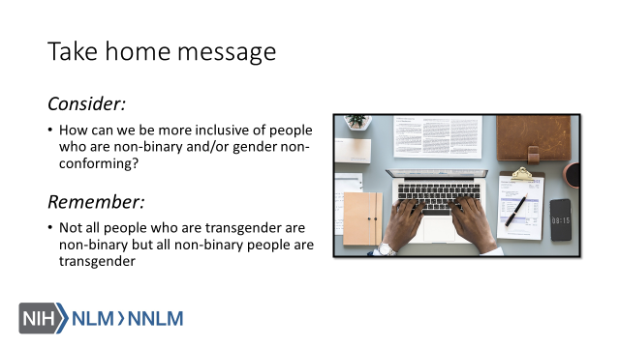

References:

- Human Rights Campaign. “LGBTQ Definition for Adults: Welcoming Schools.” Human Rights Campaign, URL to Source
- Brawbaw, Kasandra. “Allosexual, Demisexual, Bicurious - & Other Sexualities You Need to Know.” Refinery 29, 18 June 2019, URL to Source
- Brown, Eliza and Paula England. “Sexual orientation versus Behavior – Different for Men and Women?” Contexts.org, 29 February 2016, URL to Source
- California Coalition Against Sexual Assault (2017, June 28). Applying the Universe Model of Gender in Prevention [video file]. Retrieved from: URL to Source
- Trans Student Educational Resources (2019). Infographics. Retrieved from: URL to Source

