Responsibility of the Patient
- A patient must be willing to share their concerns, goals and questions¹
- Some may not want or be ready to participate²
Responsibility of the Provider
- Agree with the guiding principles of shared decision making⁴
- Build a good relationship so that patients feel supported to deliberate⁴
- Recognize patients’ ability to participate in decision making¹
- Ability to elicit patients’ preferences and communicate information about health meaningfully⁵.
SDM and Health Literacy
- Low health literacy and numeracy are barriers to shared decision making⁴
- For this reason, it is suggested that shared decision making be built on good clinical communication skills⁴:

- Communicating numbers clearly
- Summarizing options
- Open-ended questions
- Showing empathy regarding the condition²

- Universal precaution
- Avoiding medical jargon
- Providing information in small segments
- Using teach-back

SDM and Culture
- Culture may affect a patient’s values or priorities⁶
- Cultural humility is especially important in the context of shared decision making⁶

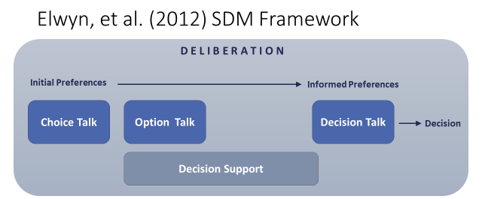
Fig 1. Elywn,G., Frosch, D., Thomson, R., Joseph-Williams, N., Lloyd, A., Kinnersley, P.,… Barry, M. (2012). Shared Decision Making: A Model for Clinical Practice, Journal of General Internal Medicine, 27(10), 1361-1367.

References:
- Agency for Healthcare Research and Quality (2019). The CAHPS Ambulatory Care Improvement Guide: Practical Strategies for Improving Patient Experience. URL to Source
- Agency for Healthcare Research and Quality (2018). The SHARE Approach. URL to Source
- Legare, F. & Thompson-Leduc, P. (2014). Twelve Myths About Shared Decision Making. Patient Education and Counseling, 96, 281-286.
- Elywn,G., Frosch, D., Thomson, R., Joseph-Williams, N., Lloyd, A., Kinnersley, P.,… Barry, M. (2012). Shared Decision Making: A Model for Clinical Practice, Journal of General Internal Medicine, 27(10), 1361-1367.
- Therialult, G., Bell, N., Grad, R., Singh, H. & Szafran, O. (2019). Teaching Shared Decision Making. Canadian Family Physician, 65, 514-516.
- Derrington, S., Paquette, E., Johnson, K. (2018). Cross-cultural Interactions and Shared Decision-making. Pediatrics, 143(s3), s187-s192.

