Hi everyone,
Thank you for attending our fifth Clinical Conversation about MI and the contemplation stage. During this conversation, we discussed different MI strategies for working with someone in contemplation. One of these was using reflective listening and summaries to help someone develop discrepancy¹. Here is a quick example of what this could look like.

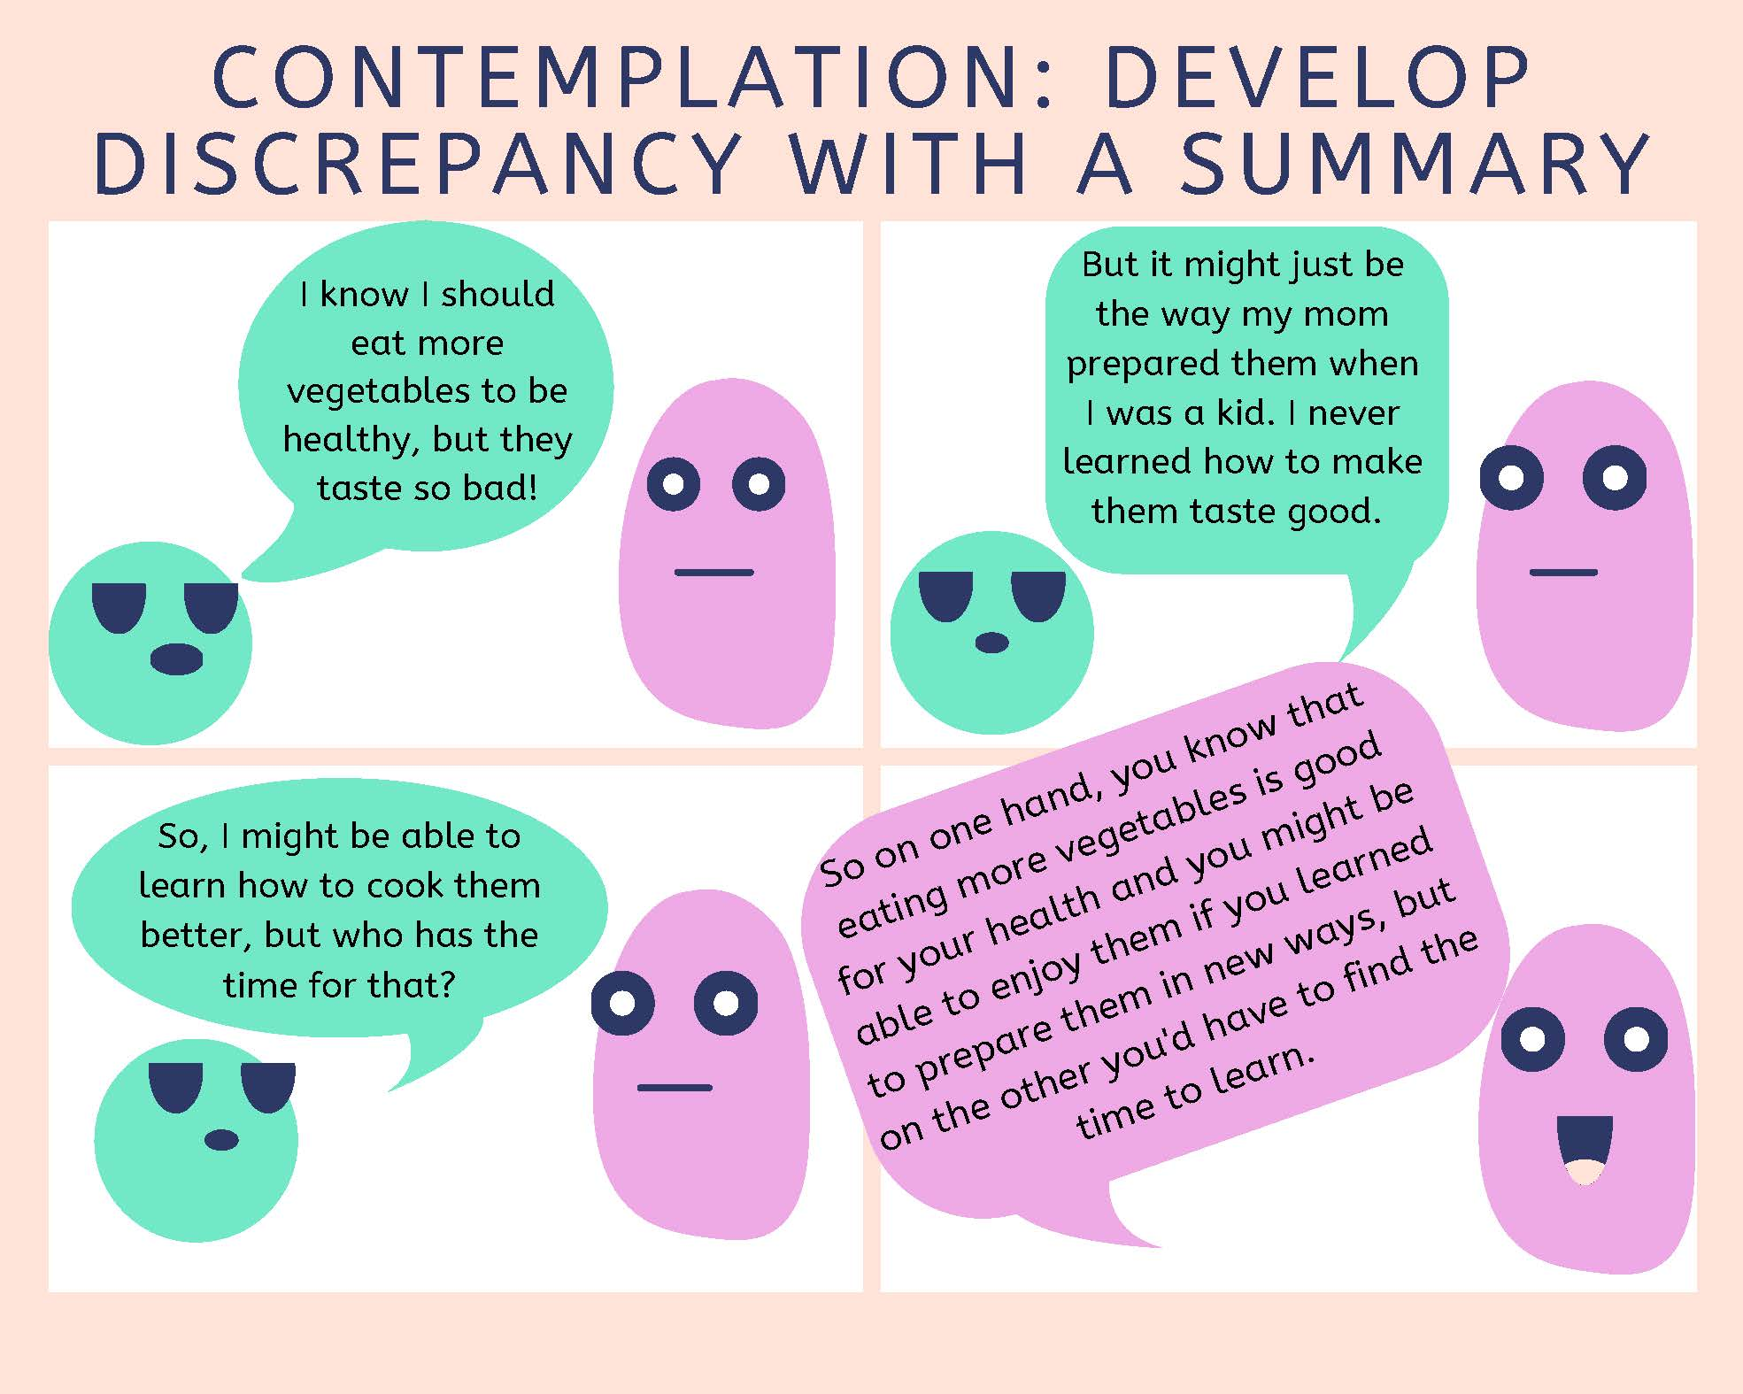

References:
- Center for Substance Abuse Treatment (1999). Enhancing Motivation for Change in Substance Abuse Treatment. Treatment Improvement Protocol (TIP) Series, No. 35. HHS Publication No. (SMA) 12-4212. Rockville, MD: Substance Abuse and Mental Health Services Administration. Retrieved from URL to Source

