What is Numeracy?
Numeracy is “the ability to comprehend, use, and ________________________ to numbers”³

Health Literacy in the U.S.
The 2003 National Assessment of Adult Literacy found that 22% of English-speaking adults in the United States had __________________________________ quantitative skills⁶

Why is Numeracy Important?
Those with low numeracy may have trouble following _______________________, leading to poorer health outcomes⁶

Better ways to communicate the numbers:
- Elaborate by providing estimated numbers
- Use _________________ instead of decimals or percentages
- Keep ______________________and timeframes the same when you compare numbers
- Give _____________________ risk instead of relative risk
- Frame _________________ in both positive and negative terms

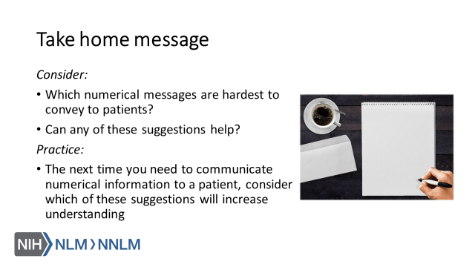

References:

- Agency for Healthcare Research and Quality (2016). Communicating Numbers to Your Patients: A Reference Guide for Health Care Providers. Retrieved from: URL to Source
- Fagerlin, A, Zikmund-Fisher, J. & Ubel, P. (2011). Helping Patients Decide: Ten Steps to Better Risk Communication. Journal of the National Cancer Institute, 103, 1436-1443. doi: 10.1093/jnci/djr318
- Food and Drug Administration (2011). Communicating Risks and Benefits: an Evidence-Based User Guide. Fischhoff, B., Brewer, N., Downs, J. (Eds.). Retrieved from: URL to Source
- Paling, J. (2003). Strategies to Help Patients Understand Risks. British medical Journal, 237, 745-748. doi:10.1136/bmj.327.7417.745
- Pleasant, A., Rooney, C., O’Leary, L., Myers, L. & Rudd, R. (2016). Strategies to Enhance Numeracy Skills. Discussion Paper, National Academy of Medicine, Washington DC. doi:10.31478/201605b
- Reyna, V., Nelson, W., Han, P., Dieckmann, N. (2009). How Numeracy Influences risk comprehension and Medical Decision Making. Psychological Bulletin, 135(6), 943-973. doi:10.1037/a0017327
- Tanne, J. (2008). Pfizer Ends Advertisements Featuring Inventor of Artificial Heart. British Medical Journal, 336(7643), 525. doi:10.1136/bmj.39509.764144.C2.
- U.S. Department of Education (2006). The Health Literacy of America’s Adults: Results from the 2003 National Assessment of Adult Literacy. Retrieved from: URL to Source

