Do you remember?
The past several modules have focused primarily on obtaining high -uality research evidence to support decision-making in EBP. However, there are two other important components of EBP that must be considered: clinical expertise and patient preference.
Clinical Expertise¹
Your clinical expertise will help you answer questions like¹:
- Does the evidence apply to this patient?
- Is the treatment appropriate for this patient?
- Can I implement it in this healthcare setting?
- What are the potential benefits and costs?
- What guidelines and protocols must I follow?
Patient Preference¹
Patient preference can encompass questions like¹:
- How can I help the patient understand the options?
- What preferences has the patient expressed?
- Does the patient have other considerations?

Shared Decision Making
Shared Decision Making is a paradigm through which healthcare providers seek to empower their patients in the decision-making process².

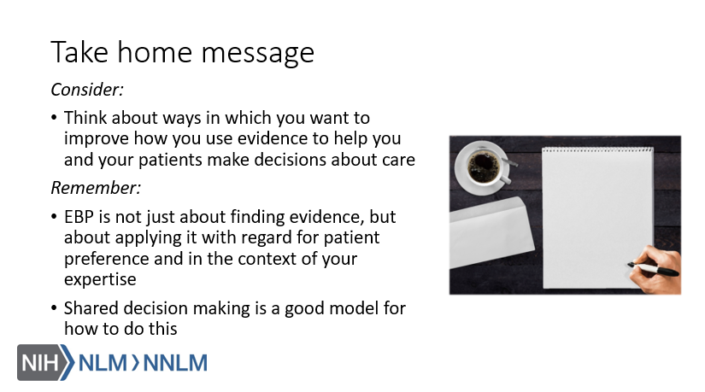
References:
- Guyatt, G.H., Haynes, R.B., Jaeschke, R.Z., Cook, D.J., Green, L., Naylor, C.D., Wilson, M.C., & Richardson, W.S. (2000). Users’ guides to the medical literature: XXV. Evidence-based medicine: Principles for applying the users’ guides to patient care. JAMA, 284(10), 1290-1296.
- Elwyn, G., Laitner, S., Coulter, A., Walker, E., Watson, P., & Thomson, R. (2010). Implementing shared decision making in the NHS. BMJ 341:c5146. DOI: 10.1136/bmj.c5146
- McCormack, J. & Elwyn, G. (2018). Shared decision is the only outcome that matters when it comes to evaluating evidence-based practice. BMJ Evidence-Based Medicine, 23(4), 137-139. DOI: 10.1136/bmjebm-2018-110922

