Hi Everyone,

Thank you for attending our final module on the social determinants of health. Here was the main take home point from this module.

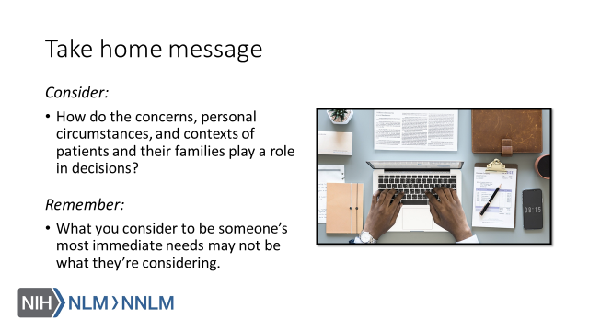

Thank you,

