Instructions for Tableau Demo
- Download “Cost of Education_TableauDemo.xls”.
- Sign in or create an account with Tableau Public.
  - https://public.tableau.com/app/discover
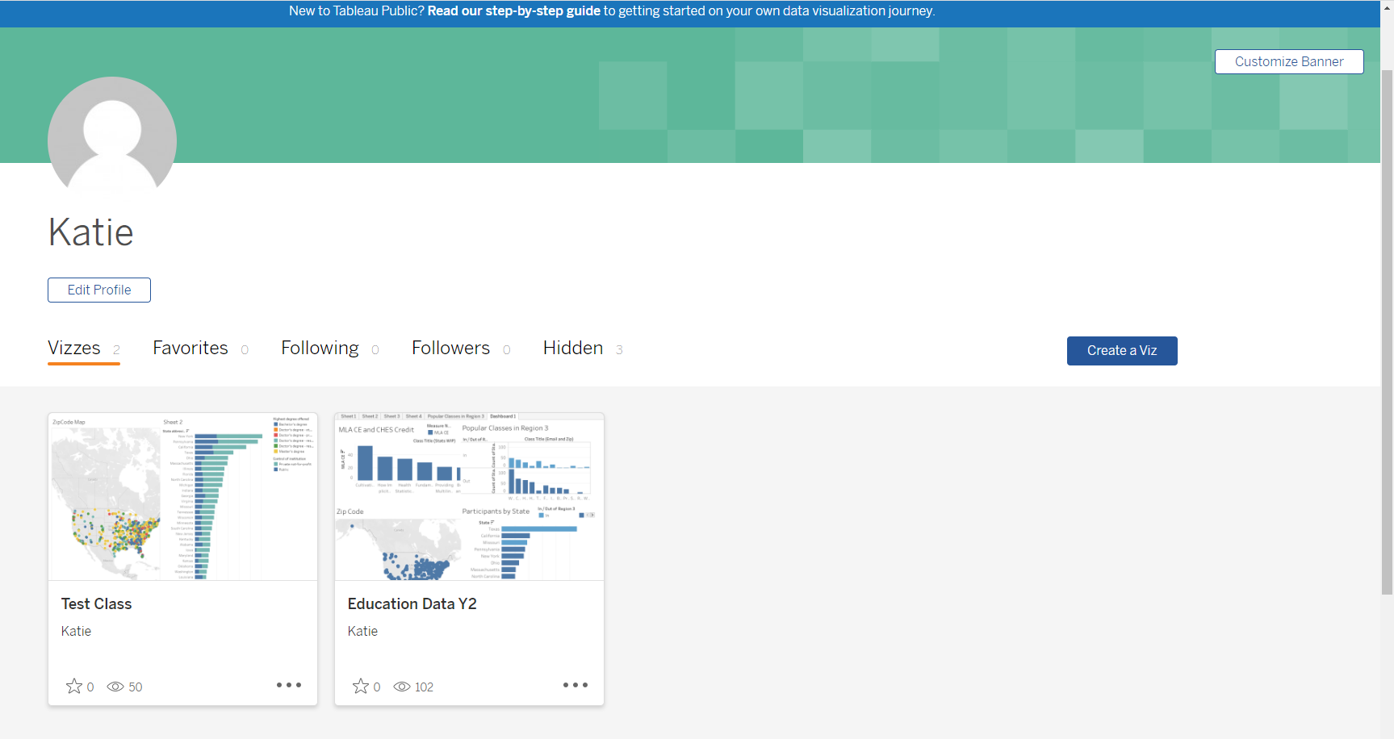
- Select Create a Viz.

- Upload “Cost of Education_TableauDemo.xls”.
- On the left, drag and the sheet labeled “Data” and drop over where it days “Drag tables here”.
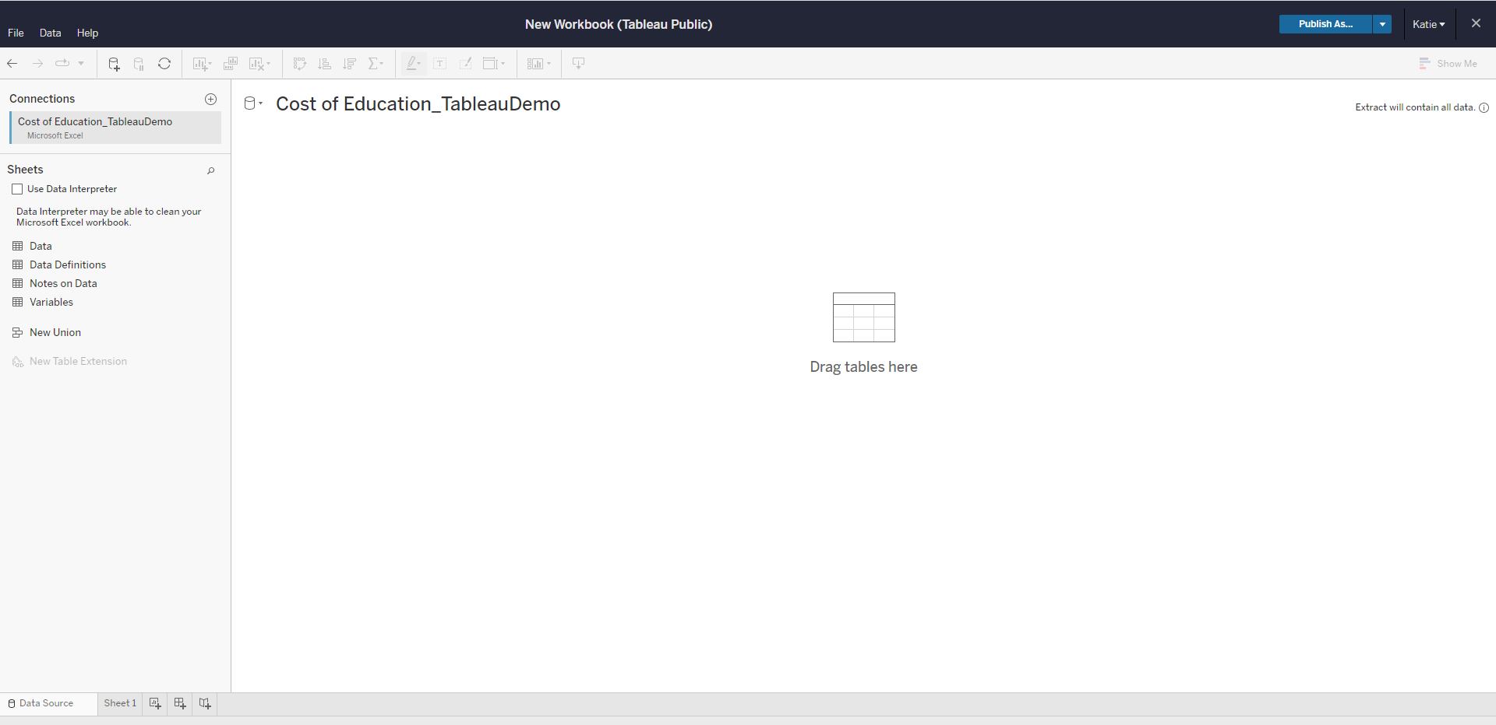
- In the top right corner select “Create Extract”. A warning will pop up. Select “Create Extract” again.
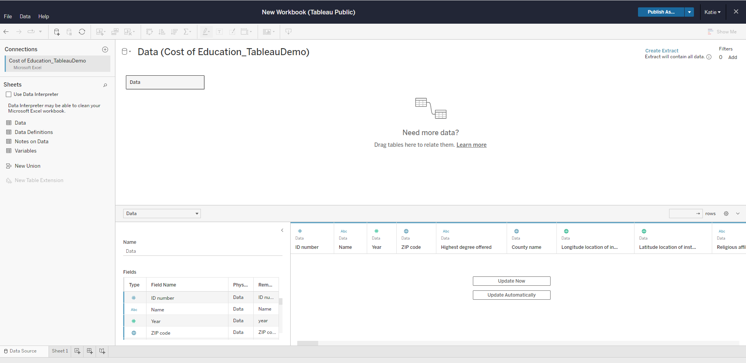
- It may take a few minutes to create the extract.
- In the top right, Select “Publish As”.
- Name the workbook.
- Select “Publish”.
- You are now ready for the Tableau. Before the session starts, login to Tableau.

