Cultural Humility History
Dr. Melanie Tervalon and Dr. Jann Murray-Garcia developed cultural humility in the 1990’s to address growing diversity in the United States and their belief that sociocultural mismatches between a patient and a provider compromise care.¹
Health Disparities
In 2003, The Institute of Medicine documented lower quality care for racial and ethnic minorities. The report defined other segments of the population receiving disparate care^{2,3}, including:
- Latinos/ Hispanics
- Members of the LGBTQIA community
- Native Americans
- People who are overweight
- Prisoners
- Some religious minorities
- Women
- African Americans
- Appalachian poor
- Asian Americans
- Elders
- Immigrants and refugees
- Individuals with disabilities

Unconscious Bias
- Research strongly suggests that unconscious or implicit biases are one of the reasons that disparities in health care persist.⁴
- It is more likely that unconscious bias will come into play when someone is stressed, tired or multi tasking.^{2,4}

Counteracting Unconscious Bias
“Counteracting unconscious bias requires awareness, introspection, authenticity, humility compassion, communication, and a willingness to act.”²

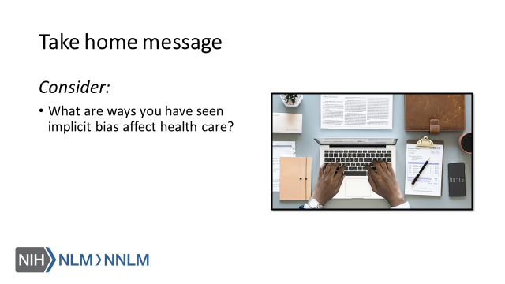

References:
- Tervalon, M., Murray-Garcia, J. (1998). Cultural Humility Versus Cultural Competence: A Critical Distinction in Defining Physician Training Outcomes in Multicultural Education. Journal of Health Care for the Poor and Underserved, 9(2), 117-125.
- White, A. & Stubblefield-Tave, B. (2017). Some Advice for Physicians and Other Clinicians Treating Minorities, Women, and other Patients at Risk of Receiving Health Care Disparities. Journal of Racial and Ethnic Health Disparities, 4, 472-479.
- Smedley, B., Stith, A., Nelson, A. (Eds.) (2003). Unequal Treatment: confronting racial and ethnic disparities in health care. Washington DC: National Academies Press.
- Byrne, A. & Tanesini, A. (2015). Instilling New Habits: Addressing Implicit Bias in Healthcare Professionals. Advances in Health Sciences Education, 20, 1255-1262.
- Chapman, E., Kaatz, A., Carnes, M. (2013). Physicians and Implicit Bias: How Doctors May Unwittingly Perpetuate Health Care Disparities. Journal of General Internal Medicine, 28(11), 1504-1510.
- Lie, D., Carter-Pokras, O., Braun, B., Coleman, C. (2012). What do Health Literacy and Cultural Competence Have in Common? Calling for a Collaborative Pedagogy. Journal of Health Communication, 12(3), 13-22.

